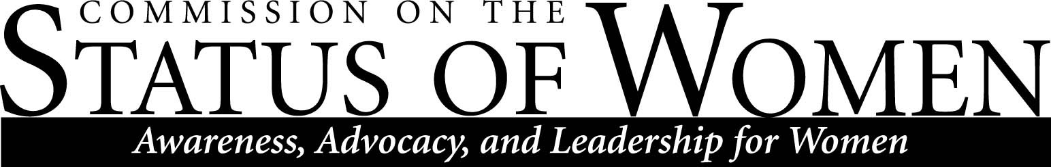

Commission on the Status of Women
Monday, January 28th 2013, 11:30 am – 12:30 pm
Location: Performing Arts 143, Conference Room

11:30 – 11:40 Introductions, updates, and announcements
- Waiting on statistical results from Karen Applebee who is doing a phenomenal job researching our questions on Gender gaps in the workforce of NAU campus.
- The Martin-Springer Speaker Series presents Dr. Zilka Spahić-Šiljak who will speak on “Women and the Concept of Compassion in Bosnia and Herzegovina” on Feb. 6, Liberal Arts Building, room 136, at 7 p.m.
  - For more information please visit: http://nau.edu/CAL/Events/Event-Pages/MSI-Speaker-Series/
11:40 – 11:50 Upcoming discussion with new women faculty, co-sponsored by AAUW and CSW
- Focusing on issues in the classroom while providing a more inclusive and social environment.
- Thoughts on developing sessions for academic and professional improvements such as
  - Seminars focused on training women and graduate/PhD students to negotiate earned salaries and contractual agreements in the workforce.
  - Seminars for undergraduates to promote themselves as professionals
11:50 – 12:10 Meeting times and priorities for the spring semester; gender gap
- Following is the CSW Spring 2013 meeting schedule (all meetings from 11:30 am-12:30 pm, location to be announced)
  - February 25th, 2013
  - March 25th, 2013
  - April 22nd, 2013

- Think about structuring CSW themes for the February Agenda
- Outline the integrated focus of CSW’s purpose with our male counterparts

12:10 – 12:30 Mason Gerety, Vice President for University Advancement
- Introduction on NAU Endowment Fund; providing single parents with an undergraduate status a $4,000 scholarship in financial aid.
  - Included in the Endowment Fund are Meal Plan scholarships averaging $1,700 per semester for students eligible for the Pell Grant Award.

Contact CSW at CSW.Office@nau.edu for more information.

The mission of Northern Arizona University's Commission on the Status of Women is to foster a positive climate that promotes full and equal opportunity for women in the university community. The Commission's objective is to educate the university community and make recommendations to the President about women's issues so that concerns in university policies, practices, and programs that affect women can be addressed to bring about constructive changes.

