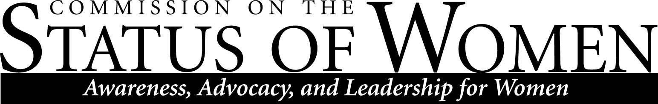
Monday, November 27, 2017, 12:00 – 1:30 p.m. | Cline Library, Room 169 (Teaching Commons)

Minutes

In attendance:
Sharon Gorman - Co-chair
Debra Edgerton - Co-chair
Michele Lee
Alexandra Carpino
Uzma Tahir
Lori Rudiner Haye
Samantha Clifford
Barbara Mendez
Nena Bloom
Kelli Smith - NAU PD Chief of Police
Missy Freshour - NAU PD Asst. Police Chief
Naomi Bishop
Bo Schwabacher
Megan Trout - Graduate Assistant
Dan Okoli, Vice President of Capital Planning and Campus Operations

- Welcome and Roll Call - Called to order at 12:05pm by Sharon Gorman, co-chair

- Announcements
  - Film Screening of "The Mask You Live In" - November 30th at 7:00pm at Firecreek in Downtown Flagstaff
  - Women of Color Symposium is tentatively set for April 14th. Working on getting Mayor Evans and Liz Archuleta to speak at one of the forums. Is CSW willing to fund an honorarium for them?
    - Angela Ray - may try to get her as keynote speaker also
    - Discussion of budget related to honorarium
    - Recommend a cap - $100 per person was proposed
      - Took a vote - All ayes, no nays
  - Planning for the Army ROTC 5K Run for Martha Portree Scholarship
    - Usually in April - date TBD
    - Martha Portree was a librarian and big supporter of education and single parents
  - Other announcements from Commissioners
    - Hermanos United for Change - Barb
    - Grad Student Government - Uzma
      - Elections early next semester
      - 3 minute presentation
        - January 28th is the deadline for the abstract
      - Local University Women group representatives attending GSG meeting on Wednesday at Ashurst
- Presentation and Discussion: Changes to the Leave of Absence Police (Diane Verkest and Cindy Chilcoat of Human Resources)
- Presentation and Discussion: NAUPD Chief of Police, Kelli Smith and the NAUPD Asst. Police Chief Missy Freshour on Policy and/or stand on how NAU police officers are being trained to handle matters on gender-related safety and harassment.
  - Review of training policies as they relate to diversity
    - By 2018, hoping to bring Bias based policing practices to campus; 16-24 hour class
    - 5 of 21 females on NAU police force
    - University safety aides to provide escorts
    - Officer representation in groups on campus such as LGBTQIA commission etc.
    - CALIA re-accreditation
      - Every 3 year file reviews, ride-alongs, forums, etc.
      - There is a report that will be issued probably end of January
    - Fair and equitable treatment
    - Coffee with a Cop outreach effort
    - 1st and 2nd in command at NAU are female
  - Open to questions
    - Statistically gender based violence has not increased (sexual assault)
      - Past couple years are higher for sexual assault but a lot are prior year crimes
      - Victim witness services has victim advocate available on campus for past 2-3 years
      - CLEERY reporting - some may be reported other ways than the police department
      - Most commonly don’t want to go through the justice system
      - ~80% involve known individuals or existing partners or alcohol
    - Hope for result of implicit bias training?
      - Scientifically based training to meet new standards
        - Cannot regulate bias, however can regulate leaving it at the door to have standardized code of conduct
      - Create awareness and self-review and reflection
      - $10,000+ cost “Fair and Impartial Policing” University of South Florida in Tampa
    - Bicycle citations
      - Grants received to do pedestrian/bike safety
- Presentation and Discussion: Dan Okoli, Vice President of Capital Planning and Campus Operations, will be speaking to us about the changes in flexible schedules for Facilities employees.
  - Mr. Okoli discussed reason for decision
    - Need for standard times and shifts
    - Need for equity, fairness, coverage, and accountability to customer needs
    - Need to request special consideration; employees were given a frame of time to submit request
    - Need to address abuse of the policy
  - Open to questions
    - How apt are you to approve? Depends on situation and not if it is open-ended
    - Open to requests? Yes, will consider new requests
    - Rransparent appeal process
- Report Out and Possible Discussion: Status on 3-4 CSW priorities for this year
Gender, Equity/Parity Committee
- Career and Leadership Workshop and/or Student Mentoring with targeted groups at NAU
- Institutional Climate on Gender and Diversity - advocating for a harassment-free environment for faculty, staff, and students, recommendations for policy changes and improved communication processes
Diversity, Health & Safety Committee
- Exit Interview - Recommendations for an improved process and instrument to incorporate more transparency and focus on issues related to diversity'
- Institutional Climate on Gender and Diversity - advocating for a harassment-free environment for faculty, staff, and students, recommendations for policy changes and improved communication processes
Work-Life Balance Committee
- Family Housing - Recommendations as a Report for continuing and sustaining family housing at NAU with supporting evidence
- Institutional Climate on Gender and Diversity - advocating for a harassment-free environment for faculty, staff, and students, recommendations for policy changes and improved communication processes

