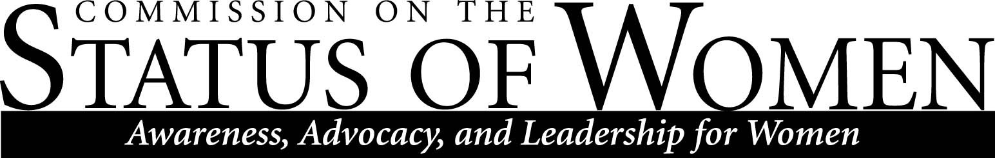

Commission on the Status of Women
Monday, December 3rd 2012, 1:30 – 2:30 pm
Location: Performing Arts 143, Conference Room

1:30 – 1:45 Introductions, updates, and announcements;
Strategic Planning participation reminder
- Karen Appleby-still collecting data-additional time given for next meeting
1:40 – 2:15 Gerald Wood from the Cultural Mapping Project
- 160 maps created-preliminary report for Office of the President
- ASWI collaborating with proposed groups on Cultural Mapping Proj.
- PTSD brought up as important issue-possible training to welcome new students
- Combined campuses walk with CDAD?
- Article introduced exploring why women are publishing less in the Science field.
2:15 – 2:20 Scholarship drive; possibilities with ASWI
- Send email appeal together with donation requests of all previous donars
2:20 – 2:30 Meeting times and priorities for the spring semester

Contact CSW at CSW.Office@nau.edu for more information.

The mission of Northern Arizona University's Commission on the Status of Women is to foster a positive climate that promotes full and equal opportunity for women in the university community. The Commission's objective is to educate the university community and make recommendations to the President about women's issues so that concerns in university policies, practices, and programs that affect women can be addressed to bring about constructive changes.

