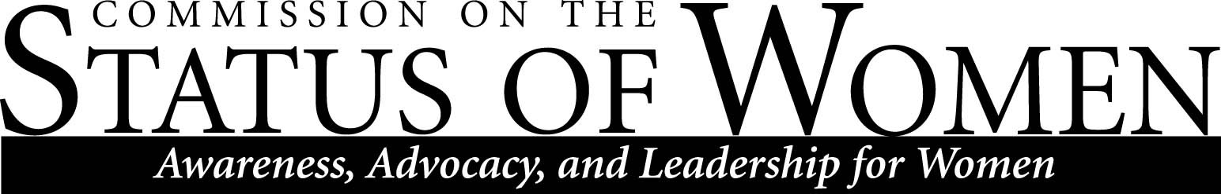

Commission on the Status of Women
Monday, April 16, 2012, 1:30 – 2:30 pm
Location: Ashurst room 109

1:30 – 1:45 Introductions and announcements
- 8 of 10 promoted to full professor at recent awards ceremony were women. Should we look into updating our data of salaries and gender? Send request to Karen Appleby
- ASWI conference was successful, had largest attendance in last 4 years. Received good feedback.
- Tonight, writer’s circle in HLC rm 203 from 5:30 to 8:30 with local author Mary Sojourner. “Empowerment is not called crazy busy”
1:45 – 2:00 CSW scholarship drive
- Portree scholarship as of March 22 only has about $200 in it. Decision was made to have a drive to raise money and postpone award until next year.
- Would like to plan a scholarship drive next year.
- Goal is to raise $5,000 to be able to give $1,000 per year
- In the past, CSW has held garage sales to raise money. Need more ideas for fundraisers.
- Is there a way we can reach out to faculty and staff? Request payroll deduction?
- Possible joint effort with ASWI? Plans to bring a musical group in mid-winter.
- Theater department has students talk with potential donors, holds a reception for donors. Can we have someone in the foundation represent us?
- Host a public speaker, ask for a donation for admission?
- Direct requests to alumni?
- Set up a facebook account with a fundraiser. Add Marilla as an administrator.
- Contact foundation rep and request she attends our first meeting next semester.
- ASWI may be able to make a donation
- Send a request for small donation from CSW commission members?
- Find a company to offer a match? Or a former CSW member?
2:00 – 2:10 Commission support for cultural mapping project
- CED is doing a project called cultural mapping. Asking student, staff, and faculty to map out “safe and unsafe” spaces on campus with regards to gender, race, ethnicity, etc.
- Brought up again that parking services has issues with unsafe spaces. Should we look into a survey about feedback for parking services?
2:10– 2:20 Report on Nominations for CSW Award
- Look at list for banquet invitations, held on Thursday April 26 at 5:30.
- Nominations are: Suzanne Botello, Erin Grisham, WGS, Dr. Clara Lovett
- Award will be given to Suzanne Botello and WGS
2:20 – 2:30 Co-chair selection for 2012-2013
- Kathleen McGeever will replace Frances as co-chair
- Julie Ann Piering will stay on as co-chair
Meetings for next semester:
September 7, 2012 11am – 12pm

Contact CSW at CSW.Office@nau.edu for more information.

The mission of Northern Arizona University's Commission on the Status of Women is to foster a positive climate that promotes full and equal opportunity for women in the university community. The Commission's objective is to educate the university community and make recommendations to the President about women's issues so that concerns in university policies, practices, and programs that affect women can be addressed to bring about constructive changes.

