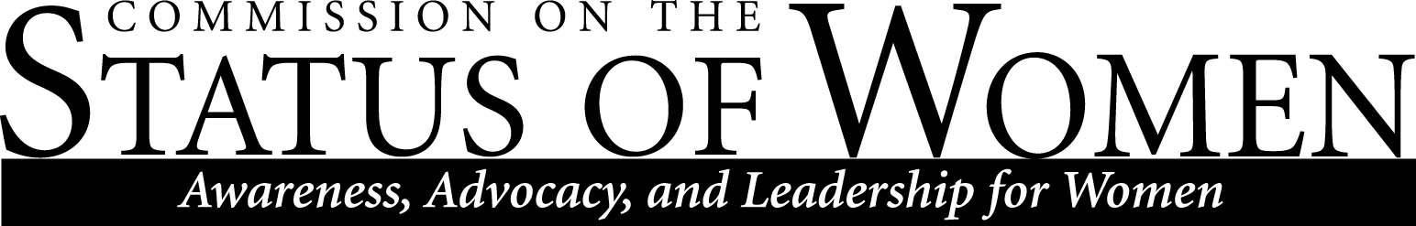

Monday, April 24, 2017
12:00 – 1:30 p.m.
Cline Library, Room 169 (Teaching Commons)

Minutes
Attendance:
- Heidi Feigenbaum; Heidi.Feigenbaum@nau.edu
- Sharon Gorman; Sharon.Gorman@nau.edu
- Jamie DeVlieger; jd434@nau.edu
- Susan Lauer; Susan.Lauer@nau.edu
- Karisma Kocos; kak456@nau.edu
- Catherine Coriell; clc588@nau.edu
- Samantha Clifford; Samantha.Clifford@nau.edu
- Lynn Jones; Lynn.Jones@nau.edu
- Carol Lorek; Carol.Lorek@nau.edu
- Anne Scott; Anne.Scott@nau.edu
- Debra Edgerton; Debra.Edgerton@nau.edu
- Nena Bloom; Nena.Bloom@nau.edu
- Danielle Gervasio; Danielle.Gervasio@nau.edu
- Mary Kate Wolter; MaryKate.Wolter@nau.edu
- Rachel Koch; Rachel.Koch@nau.edu

- Welcome and Introductions
- Announcements
  - End of term social: Tuesday May 9, 3-5pm, Grand Canyon Room

- Anne Scott, Professor, English – issues related to campus climate and harassment
  - March 2017, there was an online incendiary article published regarding a student’s essay having a point taken away due to using a non-gender neutral term, in Anne Scott’s class.
    - Using gender-neutral terms is a writing standard across MLA, APA, etc., and is a policy put forth in Anne Scott’s syllabus
  - The online article went viral, with approximately 60,000 hits within a little over a week
  - Anne Scott, her department and faculty within the department received harassing calls and emails (and as of this meeting still are)
  - Police had to be involved
  - Only when NAU campus was plastered with flyers about a “freedom rally” was Anne allowed to file for harassment- instead of three weeks prior when she asked for assistance
  - As of this meeting, no help has been forthcoming from upper level administration
  - The student responsible for starting this chain of events has not been held accountable
  - Faculty Senate has tried to address this issue, but has been received dismissively from upper level administration
  - Police have not done anything about the harassing emails and phone calls, because it needs to be a “credible threat,” or “pattern of abuse”
  - Title IX may be applicable, but this being partly a social media issue complicates it
  - Anne has been told that processes that would normally apply to the harassment of faculty on campus- SWALE- cannot help her, because of the online factor
  - If Commission members can think of any way to advocate for and provide support for Anne and her department members, Anne is open to suggestions via email or phone

- ROTC 5K Run/Walk supporting Martha Portree Scholarship on Saturday April 29
  - If you would like to volunteer to help table, please email Sharon and Heidi

- New co-chair for AY17-18
  - Vote was held during this meeting; Debra Edgerton is new co-chair

- Letter to follow-up to information we got from Mikhael Star about class scheduling off-peak hours
  - Some minor grammar and spelling was corrected
  - Please look at the letter on the BBLearn shell and email suggestions to Sharon and Heidi
  - Concerns were raised about not having any language around elder-care, and that some faculty may prefer to work during off-peak hours

- Follow-up to information we got on family housing
  - At a recent EMSA meeting, Reese Havlatka (Assistant Director, Student Conduct & Development) said there is “no need for family housing, and they are no longer accepting applications”
  - A follow up email to the person who talked to the Commission at the March meeting (Alicia Voytek) to ask about how many people are currently on the Family Housing wait list may be helpful, and to find out if this recent information about not accepting applications for Fall ’17 is true
  - Other possible contacts for this issue are the NAU community liaison, the Lumberjack newspaper and other media sources, and Deans of colleges that might be affected by this issue (i.e. graduate college)

- Diversity Strategic Plan update
  - It is being reworked and shortened, and the format is being changed
  - Progress on this will be slow but will involve more key parties on campus

Meeting ended at 1:55pm by co-chair Sharon Gorman.

