SAMPLE
REVENUE HANDLING GUIDE

DEPARTMENTAL POLICIES

The XXX Department will maintain compliance with the university’s departmental cash and check receipting policy, CMP 307, as outlined on the Comptroller’s website. Further policies that are relevant to the XXX Department are outlined below.

- Small change funds are maintained to accommodate cash transactions. Change funds are kept by the Business Office, XXX, XXX.
- Due to the nature of frequent travel in the XXX Department and the need for timely deposits that comply with University policy, the following people are authorized to review the deposit and sign as fund custodian supervisor on the deposit transmittal form:
  - Position name
  - Position name
  - Position name

REVENUE HANDLING CONTROLS
The XXX Department maintains appropriate internal controls as outlined in university policy CMP 307.

Safeguarding Assets
- The monies remain secure in a locking drawer, filing cabinet or safe at all times when not physically guarded. Deposits are not left on desks or in an in-box.
- The receipt book is safeguarded apart from revenue.
- Access to locking drawers, filing cabinets, etc. is limited.

Segregation of Duties
- Revenue receipt and deposit functions are separated between employees.

Revenue Receipts and Handling
- Checks are immediately stamped with a restrictive endorsement.
- Revenue received through the mail is logged in ink in the mail log.
- Each department maintains a pre-numbered, bound receipt book. Receipts are issued in sequential order. The original copy of the receipt is given to the walk in. The second copy is attached to the payment. The third copy is retained in the receipt book.
- All copies of voided receipts are kept in the receipt book.
- Cash over or short is handled in accordance to CMP 307.

Deposits
- Deposits are prepared on a deposit transmittal form (DTF).
- Deposits are prepared and reviewed by two separate individuals. Both sign the deposit transmittal form.
- Deposits are made in a timely manner. Northern Arizona University policy CMP 307 states “University funds are to be deposited daily with the Office of the Bursar whenever the sum of two hundred dollars or more is accumulated. Funds less than two hundred dollars may be accumulated for up to five working days. In other words, a deposit is required whenever two hundred dollars is accumulated, or five business days pass, whichever occurs first. Under no circumstances should the department hold university funds for longer than five working days from the date of collection. Deans, Department Chairs, Directors, and Fund Custodians who receive funds must assure compliance to procedure.”
- Deposits are secured in a locking bank bag for transport to the Bursar’s Office.
- The deposit is accompanied by two people to the closest depository located at XXX.

Reconciliations
- Deposit slips are reconciled to the mail log and receipt book copies on a daily basis.
- Receipt book are reviewed for completeness, retention of voids and orderly disbursement at least once per quarter.

Management Review
- Management reviews and signs the deposit reconciliations at least once per week.

PROCEDURES

REVENUE RECEIPTS
CHECKS RECEIVED THROUGH MAIL
- Mail thought to contain revenue is opened centrally for all departments.
- The mail log columns A – G are completed
  - At least two initials of the person who opened the mail
  - The date of the revenue was received
  - The amount of the payment
  - The payment number
  - Name of the person or company remitting the payment
  - The purpose of the payment
  - Initials of the person to whom the copy of the payment went
- Stamp checks with restrictive endorsement.
- Copies of checks received are made.
- Checks are hand delivered to the appropriate Business Office to be safeguarded before deposit. The Business Office initials the mail log in column H to record transfer custody of revenue.
- The copies of the checks and enclosures are distributed to the appropriate department as designated in the mail log for account coding.
- Departments review the check copy and enclosures. Account coding is noted on the copy of the check.
- The check copy is forward to the Business Office to be matched to the check for deposit by the end of the business day on which it was received.

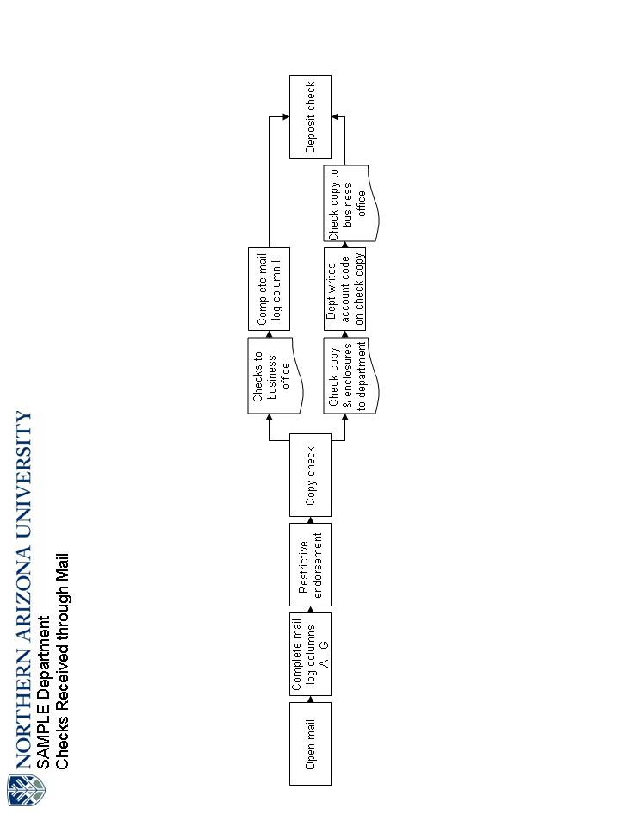
REVENUE RECEIPTS
WALK IN
- The person accepting the payment verifies the amount of the check or cash received.
- Information about the payment is noted on the receipt:
  - The date of the revenue was received
  - The amount of the payment
  - The payment number
  - Name of the person or company remitting the payment
  - The purpose of the payment
  - Method of payment
- The original copy of the receipt is issued to the customer. The second copy of the receipt is attached to revenue. The third copy remains bound in the book.
- Checks are immediately endorsed with the appropriate restrictive endorsement stamp.
- Revenue is secured.
- Second copy of the receipt is given to the appropriate person or department to assign account coding. Copy is forwarded to Business Office to be matched with revenue.
- Revenue is hand delivered to Business Office at the close of business to be matched with receipt copies and for deposit.
- The Business Office prepares the Deposit Transmittal Form.

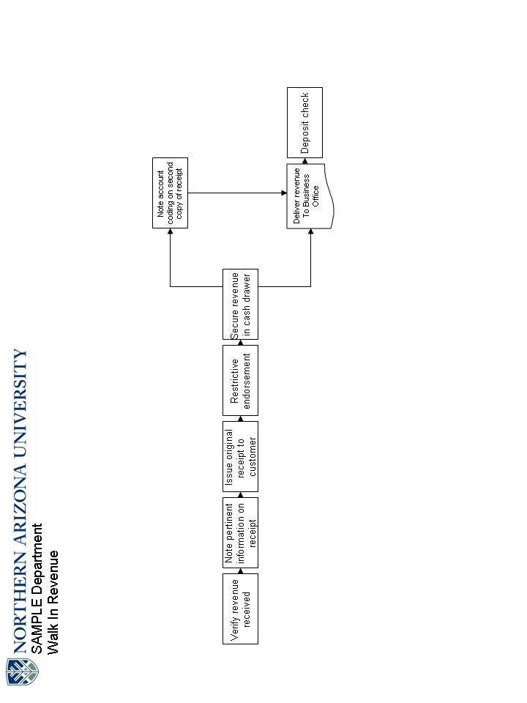
DEPOSITS
- The deposit transmittal form (DTF) is dated.
- The account coding and corresponding dollar amount for the deposit is entered.
- Total amount of cash, checks and credit cards is recorded.
- Verify that the account code distribution total dollars equals the cash, checks and credit card summary amount.
- The detailed check information is entered. If there are more than five checks, they are listed on a separate worksheet.
- Verify that the detailed check listed total equals the check total in the summary section.
- The cash custodian signs the DTF.
- The cash custodian supervisor reviews the deposit, prints and signs their name.
- Two copies of the DTF are made. One is sent with the revenue to the Bursar’s Office. One is retained in the business office.
- The revenue is placed in a locking bank bag. The original DTF and a copy are placed in the bank bag.
- The bank bag is accompanied by two people to the depository in XXX.
- One copy of the DTF is files in the business office.
- When the bag is returned, the deposit slip is filed with the DTF in the business office.

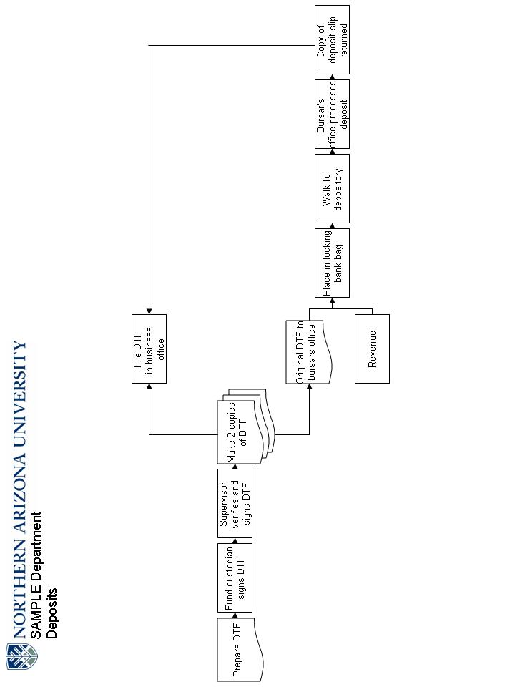
RECONCILIATION
RECONCILIATION OF MAIL LOG AND RECEIPTS TO DEPOSIT SLIP
- All items that are deposited on the same day from the mail log are totaled. The total is recorded in the “Mail Log” section of the reconciliation.
- The mail log is initialed and dated for each item reconciled.
- The total of all pre-numbered receipts copies by department for checks is verified against the check total on the deposit slip by entering the total from the receipt copies on the reconciliation form.
- The total of all pre-numbered receipts copies by department for cash is verified against the cash total on the deposit slip by entering the total from the receipt copies on the reconciliation form.
- The receipt number ranges from each department are recorded. The reconciliation form prepares a check figure to ensure all physical receipts in the range are accounted for.
- A zero difference on the reconciliation indicates no reconciling items.
- Any differences are immediately investigated and resolved.
- The completed reconciliation is printed and initialed by a supervisor and filed with the deposit backup.

REVIEW OF RECEIPT BOOKS
- Pull deposit backup from first and last days of the month.
- Verify that the beginning receipt number from the first day of the month and ending receipt number from the last day of the month match the receipt book.
- Verify that all voids are maintained in the book.
- Verify that all third copies are retained in the book and none are missing.
- Record range reviewed, date and initial on inside front cover.

