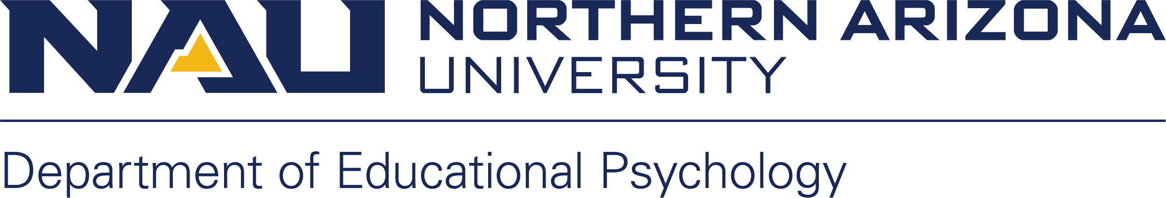

Public Purpose Rationale Instructions

An approved public purpose rationale is required prior to purchases, or processing of reimbursements.

- Please cut-n-paste the table below into an email to Hope.DeMello@nau.edu:

Department of Educational Psychology
PUBLIC PURPOSE for Request of Purchase or Reimbursement
Created 1/17/2020
Purchase or Reimbursement for what Item(s)
Dates associated with purchase or reimbursement (example: conference travel dates, event dates)
Location associated with this purchase or reimbursement (example: conference location or campus location)
How does this purchase benefit the following:
- Your Professional Development
- EPS Department
- EPS Department Programs
- College of Education
- Northern Arizona University
How will item(s) be utilized (if applicable)
Funding Source? Whose Pcard utilized?

- The public purpose rationale email will be processed/recorded in the EPS Office, and then forwarded to Dr. Horn for approval.
  - You will be cc’d on Dr. Horn’s approval/denial response email.

