TRAVEL WORKBOOK

As a university traveler, it is your responsibility to know and follow all “Traveler” policies. Policies relative to the traveler’s responsibility can be viewed at: https://nau.edu/university-policy-library/travel-policies/ (TRV-510-04 Traveler).

Arizona State Current Meals & Lodging Cost Index can be viewed on this webpage: https://nau.edu/comptroller/travel-welcome/

Link to COE & EPS Travel Forms: https://nau.edu/ed-psych/forms-checklists-manuals/
(General forms for all EPS Programs/Travel related documentation section)

Travel policy changes happen often and can affect your travel plans. This travel workbook has been created to help the travel process to be easier to navigate – ultimately it is your responsibility as the traveler to follow the above mentioned “Traveler” policies.

Pre-Travel Instructions

Your pre-travel documentation should be submitted to the EPS Department Office as far in advance of your known travel as possible, but no later than two weeks BEFORE the start of your planned travel.

Step One:
To be reimbursed for any vehicle related expenses, e.g., mileage or fuel (one or the other), parking expense, etc., or drive a university vehicle, you must be a university authorized driver (if you elect to not be an authorized driver, move to Step Two).

- Review the “Authorized Driver Program” section on the Occupational Safety webpage: https://in.nau.edu/environmental-health-and-safety/occupational-safety/
- Complete all steps through the completion of the BbLearn Defensive Driving module exam. This exam is valid for three-years from the date of completion and is tracked in the EPS Department office
- After you have completed the exam, send a screenshot of your test completion page reflecting your score to Hope.DeMello@nau.edu for department records retention (the Department Chair refers to these records before approving your Annual Travel Certificate
Step Two:
You cannot travel on university business or have travel funding approved through the department until your Annual Travel Certification form (ATC) has been approved by the EPS Department Chair (required to be completed once per academic year unless your status has changed within the academic year). If you would like to change your status in the ATC system, e.g., from non-driver to authorized driver, you will need to resubmit an ATC.
If you have already completed an Annual Travel Certificate for the current academic year, move to Step Three. If you are unsure, Hope DeMello will be able to confirm your status in the EPS Department records for the current academic year.
- The electronic Annual Travel Certification form and Instructions can be located on this webpage: https://in.nau.edu/comptroller/travel-forms/
- Please indicate Sara Abercrombie as your supervisor within the form (this is an important requirement for approval)
- Indicate whether you are to be approved as an authorized driver if you have completed STEP ONE, or you are electing to be approved as a non-driver

Step Three:
If you are traveling on university business in any capacity (conference, meeting, internship visit, etc.) you must complete a COE Travel Funding Request whether you are OR are not requesting funding for travel expense reimbursement.
- The COE Travel Funding Request can be located at this link: https://nau.edu/ed-psych/forms-checklists-manuals/ (General Forms/Travel Related Documentation section)
- This form serves as your EPS Department and NAU Record of Absence and funding verification documentation
- Please complete this form in detail. List all known funding sources, and your projected travel expenses
If you would like to drive out-of-state to your conference/meeting/event, see the “Driving Out-of-State to Your Destination:” section below.
If seeking mileage reimbursement, please consider starting and ending your travel from your duty post (campus). If you start or end your travel from your residence, commute miles will be deducted from the mileage reimbursement.
- Attach all required support documents. Refer to the “NOTE: The following support documentation should be uploaded…” section which is located on the lower half of the COE Travel Funding Request form
  - Listed below is further guidance regarding the documents that should accompany your Travel Funding Request upon submission to the EPS Department:
    - PDF of the conference/meeting/event agenda (if available)
    - PDF of the lodging page from the conference/meeting/event webpage (needed for reimbursement reference)
    - If you will be presenting at the conference/meeting/event or your research poster has been accepted for presentation, please provide a PDF of the confirmation of presentation/acceptance, or invitation to speak/present
    - Conference/meeting/event website address (if applicable/available)
    - Public purpose statement: This is a paragraph about how attendance at the conference/meeting/event will provide professional development for you as a faculty member or student
- If you have used personal funds to pay for any expenses for which you will be claiming reimbursement, e.g., conference registration, airfare, etc., attach a copy of the detailed version of the receipt(s) associated with the expense(s) to your COE Travel Funding Request when submitting the document for approval
  - Please know that reimbursement for expenses in which you have elected to use personal funds will not be reimbursed until after travel has concluded
- Submit the form and support documentation to Hope.DeMello@nau.edu for funding verification and Department Chair approval. You will be notified when the COE Travel Funding Request form has been approved at the department level
- It is a department requirement that Hope DeMello creates the travel case in the Employee Service Center system on your behalf (do not create a travel case yourself). You then can start travel arrangements through the EPS Department

Step Four:
A university Pcard must be used for travel expense payment whenever possible (university policy), e.g., conference registration, airfare. Contact Hope.DeMello@nau.edu or
928/523-7103 to arrange a time to work together to process a payment.
- Exception: Because funding is commonly limited - it is the EPS Department policy that all travelers will pay for their lodging expense using personal funds, and will be reimbursed by the NAU Travel Employee Service Center after travel has concluded, and a $0 balance receipt has been provided and uploaded to the traveler’s travel case
- Exception: If an expense is over the available funding amount, the traveler may be required to pay for the expense using personal funds and will be reimbursed by the NAU Travel Employee Service Center after travel has concluded

ADDITIONAL INFORMATION TO CONSIDER WHEN PLANNING YOUR UNIVERSITY TRAVEL

Driving Out-of-State to Your Destination:
To be eligible to claim out-of-state mileage reimbursement (or any vehicle related expense), the Employee Service Center requires that you submit a Fly vs. Drive comparison and rationale.
- The comparison should include a screenshot of the round-trip airfare expense and MapQuest trip mileage estimate created on the same calendar day. You must capture the date from the brower in which you have created the screenshot of the airfair and trip mileage estimate to verify creation date (see below circled in red). Also required is a brief rationale statement for the request to drive versus flying to the destination. In the rationale, please list any additional lodging, meal, or miscellaneous expenses that would be incurred if you drive to the destination. Example below:

Round-trip Airfare Expense Estimate:
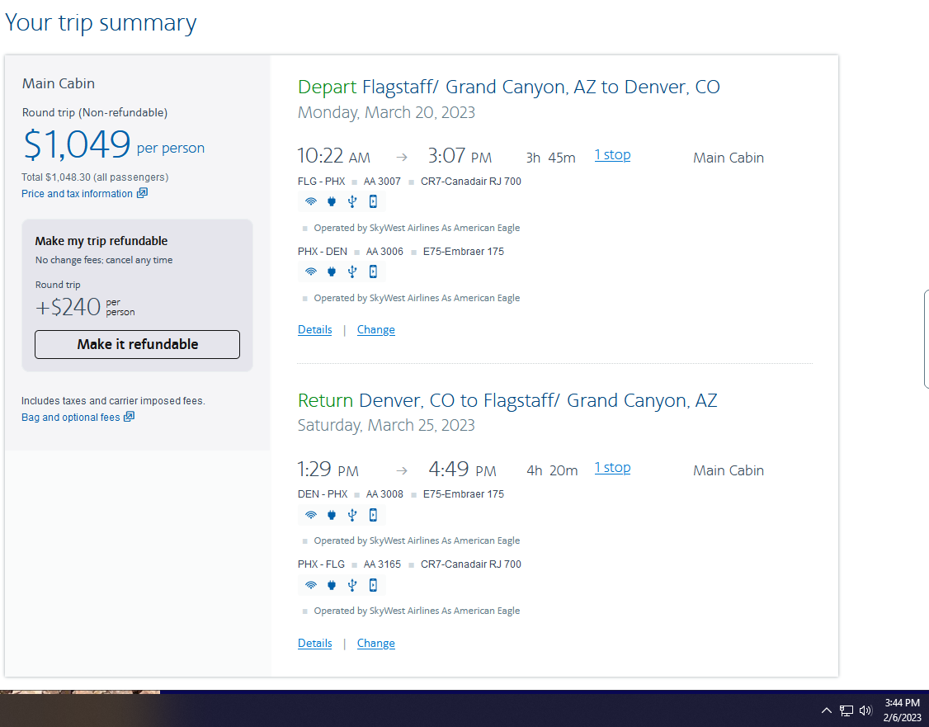
(example continued on next page)

MapQuest Mileage Expense Estimate x 2 for round-trip ($0.625/mile):
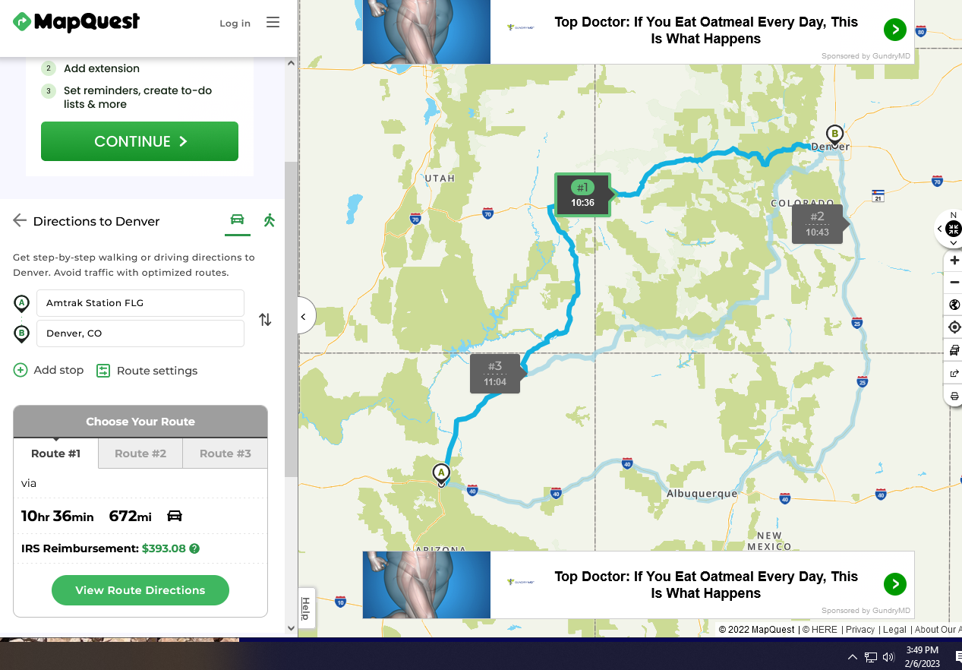
- Rationale Example: Faculty traveler would prefer to drive to conference destination, because they are traveling with an additional faculty member to the same conference, and this would be a cost savings for the department. Faculty members will incur one additional day of travel and one additional night of lodging each.
- The Fly vs. Drive comparison and rationale will be uploaded into the travel case, and the Employee Service Team will be made aware that this information is available for their consideration and approval. The EPS Department and traveler will receive communication from the Employee Service Team whether the comparison was approved or denied.

Keep Receipts for the following (if seeking reimbursement; meal receipts not required):
The EPS Department encourages you to retain all receipts for expenses associated with travel, in case expense clarification is needed. Listed below are examples of expense receipts you should retain:
- Ground transportation, e.g., taxi, Uber, subway, etc.
  - You must indicate the “from” and “to” location on ground transportation receipts
- Lodging at a $0 balance after checkout (if you paid through a travel website, e.g., Expedia, you are still required to submit a $0 balance receipt from the lodging location)
- Checked baggage receipts
Post-Travel Instructions

All post-travel forms, receipts, and documentation must be submitted to your department travel processor, Hope.DeMello@nau.edu, within four (4) business days of the completion of travel. The department travel processor must upload your forms, receipts, and documentation to your travel case before the end of the fifth business day.

Travel forms can be located on this webpage: https://nau.edu/ed-psych/forms-checklists-manuals/ (General Forms/Travel Related Documentation)

- Submit a Travel Itinerary (mandatory):
  - The Travel Itinerary can be located on the above listed link
    - Example of a completed travel itinerary is also available on the above link
  - Please refer to the instructions at the top of the form
  - Please complete this form in detail
    - Each day and every location change within each day when in travel status, along with departure and arrival times, must be reflected on the Travel Itinerary, for example:
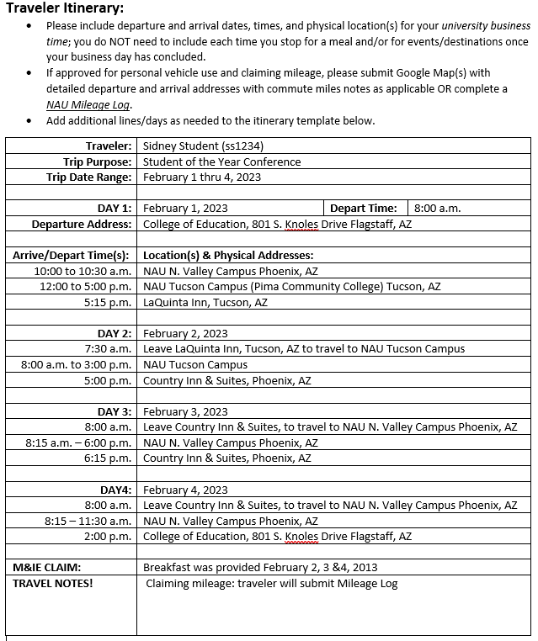
    - Add additional lines within a travel day if needed
    - Cut-n-paste additional day section(s) using the previous lines within the form if your travel continues past Day 4 – relabel newly added sections
    - Delete unused travel day sections
  - Consider reflecting your travel starting and ending at your duty post
    - If you reflect your travel starting and/or ending from your residence, commute miles will be deducted
  - If claiming meal expense reimbursement, please note what meals were provided in the “M&IE Claim” section of the form
  - If claiming mileage reimbursement using odometer readings use the Mileage Log (instructions in next section)
  - If claiming mileage not using odometer readings, you will need to provide a Google Maps or MapQuest printout to accompany your trip itinerary (for a round-trip mileage reimbursement, a one-way mileage printout will suffice)
- Mileage Log (if claiming mileage using odometer readings):
  - The Mileage Log can be located on the above listed link
  - Odometer readings are required for this form
- Lodging Receipt (if claiming lodging reimbursement):
  - Provide a lodging receipt reflecting a $0.00 balance after check-out
- Ground Transportation (if claiming reimbursement):
  - Original receipts are preferred for reimbursement submission
- Miscellaneous receipts for travel expenses (if claiming reimbursement):
  - Original receipts are preferred for reimbursement submission

REMEMBER -- Travel policy changes happen often and can affect your travel plans. This travel workbook has been created to help the travel process to be easier to navigate – ultimately it is your responsibility as the traveler to follow the “Traveler” policies on the link below:

https://nau.edu/university-policy-library/travel-policies/ (TRV-510-04 Traveler).

