TRAVEL WORKBOOK

As a university traveler, it is your responsibility to know and follow all “Traveler” policies. Policies relative to the traveler’s responsibility can be viewed at: https://nau.edu/university-policy-library/travel-policies/ (TRV-510-04 Traveler).

Arizona State Current Meals & Lodging Cost Index can be viewed on this webpage: https://nau.edu/comptroller/travel-welcome/

Link to COE & EPS Travel Forms: https://nau.edu/ed-psych/forms-checklists-manuals/
(General forms for all EPS Programs/Travel related documentation section)

Travel policy changes happen often and can affect your travel plans. This travel workbook has been created to help the travel process to be easier to navigate – ultimately it is your responsibility as the traveler to follow the above mentioned “Traveler” policies.

IMPORTANT POLICY CHANGES AS OF JULY 1, 2023

- Travelers are no longer allowed to use personal funds to purchase conference registration, transportation to/from an event or conference (example: airfare, train fare, etc.). If you are requesting lodging expense reimbursement, your remaining funding must be applied towards lodging (the traveler will be required to pay the remainder of the lodging expense not covered by NAU funding). These expenses must be purchased using the department travel processor’s Pcard

- Do not use any frequent flyer number, hotel rewards number, etc., for any expense paid using university funds (completely or in-part)

Department of Educational Psychology Travel Processor is Hope DeMello, and she can be contacted at Hope.DeMello@nau.edu or 928/523-7103.
Pre-Travel Instructions

Your pre-travel documentation should be submitted to the EPS Department Office as far in advance of your known travel as possible, but no later than two weeks BEFORE the start of your planned travel.

Step One:
To be reimbursed for any vehicle related expenses, e.g., mileage or fuel (one or the other), parking expense, etc., or to drive a university fleet vehicle, you must be a university authorized driver (if you elect to not be an authorized driver, move to Step Two).

Before you start the process listed below - If you have been an authorized driver in the past, and think your Defensive Driving Module might still be valid, contact Hope DeMello. She will be able to verify the status of your Defensive Driving Module, and ensure the EPS Department has a copy of your module exam results on file. If your Defensive Driving Module is still valid, start this process at Step Two, and select the “Authorized Driver” option within the Annual Travel Certification form.
- Review the “Authorized Driver Program” section on the Occupational Safety webpage: https://in.nau.edu/environmental-health-and-safety/occupational-safety/
- Complete all steps through the completion of the Canvas Defensive Driving module exam. This exam is valid for three-years from the date of completion and is tracked in the EPS Department office
- After you have completed the exam, send a screenshot of your test completion page reflecting your score to Hope.DeMello@nau.edu for department records retention. The Department Chair will refer to these records before approving your Annual Travel Certificate
Step Two:
You cannot travel on university business or have travel funding approved through the department until your Annual Travel Certification form (ATC) has been approved by the EPS Department Chair (required to be completed once per academic year unless your status has changed within the academic year). If you would like to change your status in the ATC system, e.g., from non-driver to authorized driver, you will need to resubmit an ATC.
If you have already completed an Annual Travel Certificate for the current academic year, move to Step Three. If you are unsure, Hope DeMello will be able to confirm your status in the EPS Department records for the current academic year.
- If you plan to be a university authorized driver, DO NOT complete this annual travel certification form until you have completed the authorized driver process; unless your defensive driving module is still valid (Hope DeMello can confirm the status of your module)
- The electronic Annual Travel Certification form and instructions can be located on this webpage: https://in.nau.edu/comptroller/travel-forms/
- Please indicate Sara Abercrombie as your supervisor within the form (this is an important requirement for approval)
- Indicate whether you are to be approved as an authorized driver if you have completed STEP ONE, or you are electing to be approved as a “non-driver”
Step Three:
If you are traveling on university business in any capacity (conference, meeting, internship visit, etc.) you must complete a COE Travel Request form whether you are OR are not requesting funding for travel expense reimbursement.
- The COE Travel Request form can be located at this link: https://nau.edu/ed-psych/forms-checklists-manuals/ (General Forms/Travel Related Documentation section)
- This form serves as your EPS Department and NAU Record of Absence and funding verification documentation
- Please complete this form in detail. List all known funding sources, and your projected travel expenses, personal days you may be taking within this travel timeframe, etc.
  - If membership renewal/purchase is required as part of conference registration, in the “TRAVEL REQUEST WILL EMCOMPASS THE FOLLOWING:” section of the COE Travel Request form, check “□ Other” and list Membership
- The Department of Educational Psychology requires the following support documents to be submitted along with your COE Travel Request form:
  - PDF of the conference/meeting/event agenda (if available)
  - PDF of the lodging page from the conference/meeting/event webpage (needed for reimbursement reference)
  - If you will be presenting at the conference/meeting/event or your research poster has been accepted for presentation, please provide a PDF of the confirmation of presentation/acceptance, or invitation to speak/present letter or email
  - If you have received additional funding from any NAU departments/colleges or outside entities, please send your award letters/emails to me to be included in your travel case
  - Double/Multiple-Occupancy Attestation if planning to share a hotel/motel room with another NAU traveler/travelers (see restrictions below)
  - Single-Family Home or Shared Living Residence Attestation if planning to share an Airbnb type lodging with another NAU traveler/travelers (see restrictions below)
- Submit the form and support documentation to Hope.DeMello@nau.edu for funding verification and Department Chair approval. You will be notified when the COE Travel Request form has been approved at the department level, and your travel case has been built in the Employee Service Center system
- It is a department requirement that Hope DeMello creates the travel case in the Employee Service Center system on your behalf (do not create a travel case yourself)
  - After approval of this document by the EPS Department and COE Fiscal Oversight Manager, you then can start travel arrangements through the EPS Department
ADDITIONAL INFORMATION TO CONSIDER WHEN PLANNING YOUR UNIVERSITY TRAVEL
Driving Out-of-State to Your Destination:
To be eligible to claim out-of-state mileage reimbursement (or any vehicle related expense), the Employee Service Center requires that you submit a cost comparison and rationale
- NAU Travel: Cost Comparisons – How to run instructions are available on the EPS Website: https://nau.edu/ed-psych/forms-checklists-manuals/ (General Forms for EPS Department & All EPS Programs; under Travel Related Documentation heading)
  - You must submit this cost comparison along with your travel funding request, because it has to be immediately uploaded into your travel case
Lodging Information:
- Lodging arrangements MUST be able to be changed, cancelled and fully-refunded.
- If a credit card authorization has been submitted on your behalf by the EPS Travel Processor to cover the expense of your lodging, and you provide your “rewards” number for that lodging establishment upon check-in, the credit card authorization will automatically be voided in the payment system by the establishment. You then will be responsible to pay for the lodging expense using personal funds. After you return from your trip, you must submit a Policy & Compliance Review (PCR) request, with an explanation why you used personal funds to pay for your lodging, even though a credit card authorization was submitted for payment
- You may be asked to put a credit card on file upon check-in at the hotel relative to incidental expenses. If you use a debit card for this process, the lodging establishment will place a hold on your debit card for the total expense total of your stay, and commonly the hold will remain in place for several days after checkout even if the expense has been paid via NAU Pcard credit card authorization
- If planning to share a shared commercial lodging space, e.g., Hotel or Motel, etc., the following must be followed:
  - All occupants of the shared lodging space must be over the age of 18
  - A Double/Multiple-Occupancy Attestation form must be submitted with the COE Travel Request by each NAU traveler – whether receiving NAU funding or not
  - If NAU funding is being used towards the lodging expense in any part, the NAU traveler’s name must appear on the $0 balance commercial lodging receipt, which should be forwarded to Hope DeMello upon completion of travel

- If planning to share a shared lodging space, e.g., VRBO or AirBnB, etc., the following must be followed:
  - All occupants of the shared lodging space must be over the age of 18
  - A Single-Family Home or Shared Living Residence Attestation form must be submitted by the traveler at the same time as the COE Travel Request – whether receiving NAU funding or not
  - If all travelers staying at the shared lodging are requesting funds to be used towards lodging expense, and all travelers have enough NAU funding to cover the total expense, the EPS Department must book the AirBnB or VRBO
  - If travelers who will be staying in the shared lodging and seeking lodging expense reimbursement, but do not have enough funding to cover their share of the expense, they must work with the EPS Travel Processor to submit a Policy & Compliance Review (PCR) asking for approval to use personal funds for lodging expense payment and permission to seek partial reimbursement of the expense
A PCR is also required If the shared lodging is booked by an NAU traveler using personal funds, and other occupants of this shared lodging space will be reimbursing the traveler who booked the residence for their share of the expense. Proof of payment to the traveler who booked the shared lodging from the occupant MUST be provided if the occupant is seeking reimbursement for this payment using NAU funds (completely or partial). Proof of payment might be a photocopy of check, screenshot of Venmo fund transfer of payment, etc., a signed receipt from the travel who booked the shared lodging stating that the occupant had provided payment for their share of the shared lodging expense. This documentation will need to be uploaded into the traveler’s travel case along with the approved PCR for reimbursement of the lodging expense
    - If the PCR is not approved, the traveler will not be reimbursed for this expense even though personal funds were used to pay for this expense
    - IF the PCR is approved, and the shared lodging is booked using personal funds, the traveler staying in the shared lodging can seek partial reimbursement for their share of the lodging expense

Airfare:
- The flights you select must be changeable. When identifying your preferred flights, and calculating the expense, you must select a basic economy fare that can be changed
- If the airfare is refundable, and if a refunded is processed as an airfare credit to the traveler, but not the original payment source (university Pcard), the traveler is required to reimburse the EPS Department for this expense
- Be aware that when you incorporate personal days within university travel, an airfare comparison must be submitted. Please discuss this with the department travel processor
Keep Receipts for the following (if seeking funding use or reimbursement; meal receipts not required):
The EPS Department encourages you to retain all receipts for expenses associated with your travel, in case expense clarification is needed. Itemized receipts are required and must reflect proof of payment.
Listed below are examples of expense receipts you should retain:
- Ground transportation, e.g., taxi, Uber, subway, etc.
  - You must indicate the “from” and “to” locations on ground transportation receipts
- Lodging at a $0 balance after checkout. The traveler’s name must appear on the receipt
- The traveler must review the lodging receipt for errors at the time of check-out, and bring a $0 balance receipt back to the EPS Department Travel Processor to be included in the travel case
- Checked baggage receipts

Please review the post-travel instructions on the next page to be aware of your responsibilities
Post-Travel Instructions

All post-travel forms, receipts, and documentation must be submitted to your department travel processor, Hope.DeMello@nau.edu, within four (4) business days of the completion of travel. The department travel processor must upload your forms, receipts, and documentation to your travel case before the end of the fifth business day.

Travel forms can be located on this webpage: https://nau.edu/ed-psych/forms-checklists-manuals/ (General Forms/Travel Related Documentation).

- Submit a Travel Itinerary (mandatory):
  - The Travel Itinerary can be located on the above listed link
    - Example of a completed travel itinerary is also available on the above link
    - Please refer to the instructions at the top of the form
    - Please complete this form in detail
      - Each day and every location change within each day when in travel status, along with departure and arrival times, must be reflected on the Travel Itinerary, for example:
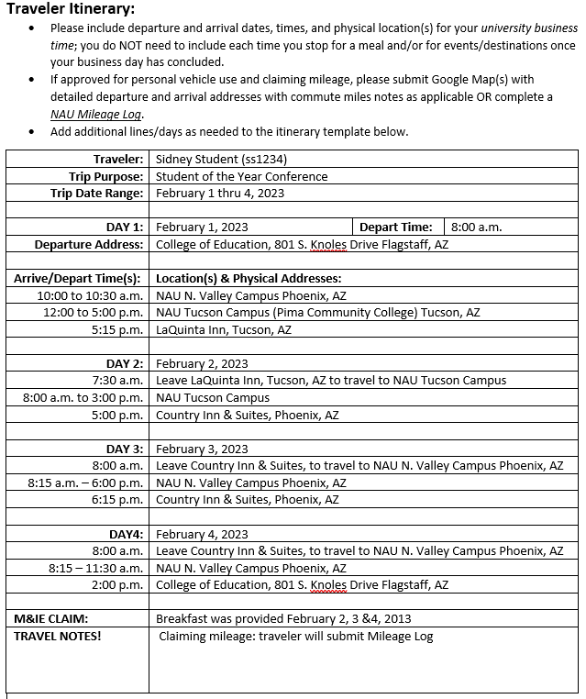
    - Add additional lines within a travel day if needed
    - Cut-n-paste additional day section(s) using the previous lines within the form if your travel continues past Day 4 – relabel newly added sections
    - Delete unused travel day sections
  - Consider reflecting your travel starting and ending at your duty post
    - If you reflect your travel starting and/or ending from your residence, commute miles will be deducted
  - If claiming meal expense reimbursement, please note what meals were provided in the “M&IE Claim” section of the form
  - If claiming mileage reimbursement, note that in the “comments” section of the form
- Mileage Reimbursement:
  - Remember: You MUST be a university authorized driver to be reimbursed for any vehicle related expenses, e.g., mileage, parking, etc.
  - If using odometer readings for mileage reimbursement, use the Mileage Log
    - The Mileage Log can be located on the above listed link
  - If not using odometer readings, you will need to provide a Google Maps or MapQuest printout to accompany your trip itinerary (for a round-trip mileage reimbursement, a one-way mileage printout will suffice)
- Lodging Receipt (if claiming lodging expense payment):
  - Provide a lodging receipt reflecting a $0.00 balance after check-out. Provide a copy of this receipt to the EPS Department Travel Processor
- Ground Transportation (if claiming reimbursement):
  - Original receipts are preferred for reimbursement submission, and you must note the starting and end locations on each receipt
- Miscellaneous receipts for travel expenses (if claiming reimbursement):
  - For example: checked bag fees, etc.
  - Original itemized receipts are preferred for reimbursement submission

REMEMBER -- Travel policy changes happen often and can affect your travel plans. This travel workbook has been created to help the travel process to be easier to navigate – ultimately it is your responsibility as the traveler to follow the “Traveler” policies on the link below:

https://nau.edu/university-policy-library/travel-policies/ (TRV-510-04 Traveler)

