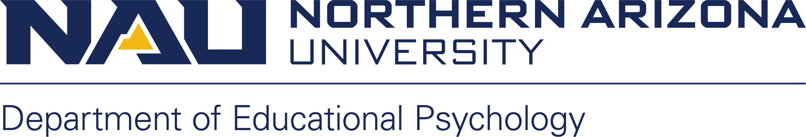

Double/Multiple-Occupancy Attestation

I acknowledge I have agreed to share hotel/motel lodging with a person(s), of which is/are over the age of 18.

I acknowledge that I have had a chance to read the university's Sexual Misconduct Policies:
- https://nau.edu/university-policy-library/sexual-misconduct/
- https://nau.edu/university-policy-library/nondiscrimination-anti-harassment/

I knowingly and voluntarily assume the risk and choose to share lodging in this setting.

______________________________________________ _____________________
Signature (Physical Signature Required; Electronic Signature NOT Accepted) Date

