CACREP Programs’
Student Handbook for 2023-2024
Revised October 2023

Purpose of Handbook:
To orient all Clinical Mental Health Counseling and School Counseling students in accordance with major CACREP Program policies in accordance with CACREP (2016) Section 1 (The Learning Environment) standards 1.M and 1.N as shown below.
Programmatic policies designed to meet CACREP Standard M: Before or at the beginning of the first term of enrollment in the academic unit, the program provides a new student orientation during which a student handbook is disseminated and discussed, students’ ethical and professional obligations and personal growth expectations as counselors-in-training are explained, and eligibility for licensure/certification is reviewed.

M.1.a Handbook is disseminated during the initial new cohort Orientation mandatory meeting each new academic year. Those unable to attend the meeting for whatever reason are required to watch the recording of the meeting within one week.

M.1.b Students ethical and professional obligations and personal growth as CIT’s are explained during the initial orientation meeting, and are reiterated in the first weeks of the
Introduction/Orientation class meetings (EPS 592 for CMHC, and EPS 594 for SC). Personal growth expectations are also discussed in individual advisement meetings, and at the end of each fall and spring semester, students receive their Professional Disposition Evaluations from their advisor - PDE’s are emailed to each student in the form of the PDE Qualtrics survey. Students who are struggling significantly in either academic, interpersonal, or intrapersonal domains may

M.1.c Eligibility for licensure and certification are reviewed in the handbook below and are discussed in initial class meetings in EPS 592 and 594.

Programmatic policies designed to meet Standard N:
To provide a student handbook that includes:
- The mission statement of the academic unit and program objectives
- Information about professional counseling organizations, opportunities for professional involvement, and activities appropriate for students
- Matriculation requirements
- Expectations of students
- Academic appeal policy
- Written endorsement policy explaining the procedures for recommending students for credentialing and employment, and
- Policy for student retention, remediation, and dismissal from the program

N.1.a. The Mission Statement of the Academic Unit and Program Objectives: The mission of the Council for the Accreditation of Counseling and Related Educational Programs (CACREP) accredited master’s programs is to prepare professional counselors who meet national standards of the National Board of Certified Counselors (NBCC) as well as state counseling licensure or certification in their specialty area. Our programs are designed to be comprehensive in nature and to focus on the development of evidence-based counseling practice in a variety of settings and with clients from culturally diverse backgrounds.

N.1.b Objectives for School Counseling and Clinical Mental Health Counseling Programs
Successful completion of the Master of Arts in Clinical Mental Health Counseling and the Master of Education in School Counseling prepares students to:
- Understand the requirements for being a professional counselor, including the relevant research and literature pertinent to the discipline.
- Become knowledgeable about the nature and needs of individuals at all developmental levels.
- Develop a thorough understanding of knowledge and competencies related to issues and trends in a multicultural and pluralistic society, and to effectively demonstrate multicultural counseling competencies.
- Demonstrate effective counseling skills.
- Become familiar with studies in group dynamics and demonstrate effective group counseling skills.
- Understand major theories of career development and related life factors, and to demonstrate effective career counseling skills.
- Develop an understanding of assessment processes, and to demonstrate skills in individual and group approaches to assessment and evaluation.
- Understand research, statistics, and program evaluation, especially as they apply to the practice of counseling.
- Develop a clear sense of professional identity in counseling, which includes professional ethics, legal responsibilities, professional preparation standards, participating in professional organizations, and obtaining necessary credentials.
- Understand the process of counseling supervision and receive supervision from peers, site supervisors, and faculty, allowing students to integrate and apply the knowledge and skills they have acquired throughout their experience.
- Use a feedback informed process on experiential learned course material to further one’s development in the program.
- Acquire knowledge and skills related to the ways that counselors use a variety of technologies designed to assist students, clients, and the systems they work within.
- Acquire knowledge related to the professional identity, roles, and functions of professional counselors.
- Practice ongoing self-assessment, strengths, weaknesses, professional and personal development as related to counseling professional identity, counseling ethics, and the overarching principles of ethics of client autonomy, non-maleficence, beneficence, justice, and fidelity.

N.2. Information about professional counseling organizations, opportunities for professional involvement, and activities appropriate for students

1. National:
§ American Counseling Association (www.counseling.org)
- NAU Counseling students are expected to join ACA during their master’s program. Students are required to have liability insurance for practicum and internship experiences. Joining ACA, at the student membership rate, allows you to obtain liability insurance at a discounted rate.
§ American Mental Health Counselors Association (www.amhca.org)
- Students in the Clinical Mental Health programs are encouraged to join AMHCA but not required.
- American School Counseling Association (www.schoolcounselor.org)
  - All School Counseling students will receive free access to AzSCA starting fall 2020.
- Chi Sigma Iota at Flagstaff Campus (website: https://www.csi-net.org/member/beta_alpha)
  - NAU Beta Alpha chapter of Chi Sigma Iota (National Honor Society for Counseling students) at our Flagstaff campus.
          - Active since 2014
            - Conducts multiple presentations for CSI students and local counselors
            - Holds multiple service projects, fundraisers, and social events
- State:
- Arizona Counseling Association
  - All active NAU CACREP students are automatically enrolled in AzCA as members each fall and will receive their membership information from AzCA directly.
- Arizona School Counselors Association
  - All active NAU CACREP students are automatically enrolled in AzSCA as members each fall and will receive their membership information from AzSCA directly.
- Local:
- Counseling Club at North Valley & Tucson Statewide Campus
      - Newly formed in 2023 this group is for all Clinical Mental Health & School Counseling students to hold social events, service projects, presentations etc.

N.3 Matriculation Requirements

Academic Requirements

Northern Arizona University expects students to have adequate undergraduate preparation for their intended major. Generally, the student must have at least the equivalent of an undergraduate minor (18 units), and the student's advisor or academic unit may require that the student take, as a prerequisite for graduate study, any undergraduate course normally required of undergraduate majors in the field.

All graduate students must adhere to the academic requirements and criteria outlined by their program, Graduate College, and NAU. See NAU Policy 100319: Academic Continuation, Probation, Dismissal, and Readmission - Graduate for more detailed information.

Graduate students must, at a minimum, meet the “Academic Requirements for Continuation in a
Graduate Program” found in NAU Policy 100319: Academic Continuation, Probation, Dismissal, and Readmission - Graduate, in order to graduate. To begin the graduation process, please see NAU Policy 100334: Applying for Graduation, Graduate Students.

Additional Admission Requirements
Admission requirements over and above admission to NAU are required.
- NAU Graduate Online application is required for all programs. Details on admission requirements are included in the online application.
- Undergraduate degree from a regionally accredited institution
- Grade Point Average (GPA) of 3.00 (scale is 4.00 = "A"), or the equivalent.
- Admission to many graduate programs is on a competitive basis, and programs may have higher standards than those established by the Graduate College.
- Transcripts
- For details on graduate admission policies, please visit the Graduate Admissions Policy
- International applicants have additional admission requirements. Please see the International Graduate Admissions Policy
Individual program admission requirements include:
- GRE® revised General Test for applicants with a GPA lower than 3.0.
- 3 letters of recommendation
- Responses to specific essay questions
- IVP Fingerprint clearance card
- Candidate interview
- Program Prerequisite course: EPS 525 or successful completion of an upper-division undergraduate Statistics course within the past three years of admittance.

Matriculation
• Students in the master’s CMHC or SC programs are required to:
- successfully completed all 60 credits, including passing Practicum and Internship (program of study outlined in following pages)
- earn no more than 2 C’s on their transcript
- earn A’s or B’s in all skills courses
- Students in the School Counseling program are required to pass EPS 660, 661, and receive passing grades in Practicum and Internship. A fingerprint clearance card is also required to begin the practicum experience (see Fingerprint clearance card section below).
- Students in the Clinical Mental Health program are required to pass EPS 660, 661, 681, and receive Passing grades in Practicum and Internship. A fingerprint clearance card is also required to begin the practicum experience (see Fingerprint clearance card section below).
- Students are required to enroll in two semesters of internship with each course being 3 credit hours. Internship classes are usually 15 weeks in length per semester. In accordance with CACREP guidelines, students are required to complete a field experience internship in their supervised area prior to graduation. Students must complete a minimum of 600 hours in a supervised counseling internship, of which, at least 240 hours must be direct service with actual clients.
- Students in CMHC and SC programs who do not meet program requirements will be placed on
a Professional Growth Plan (PGP) that must successfully completed to remain in good standing
- Program of Study
      - Program of Study for Clinical Mental Health and Counseling, School Counseling program may be found here: https://nau.edu/graduate-college/programs-of-study/

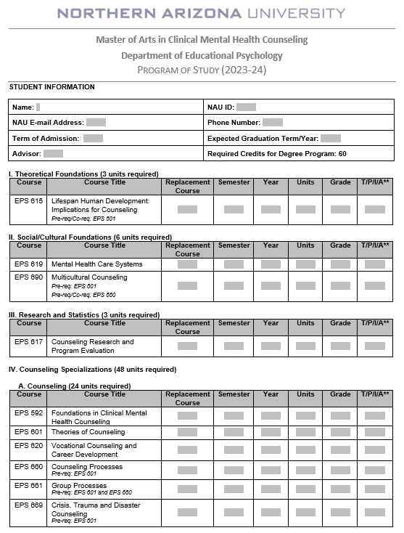

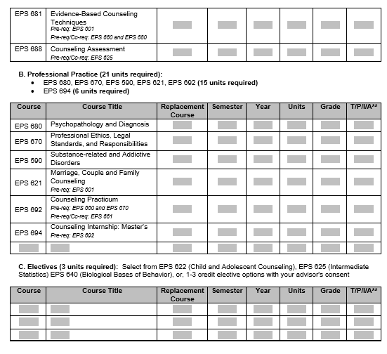

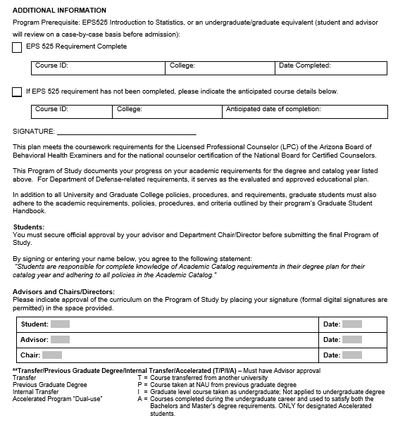
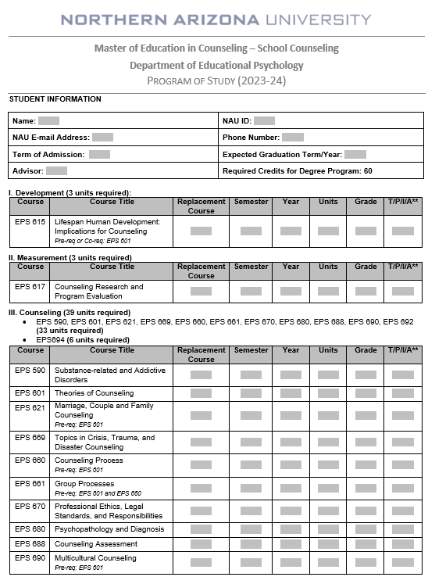

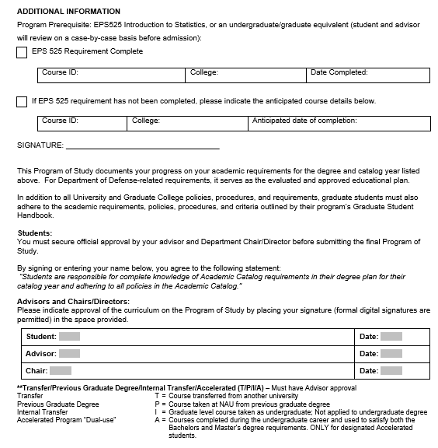
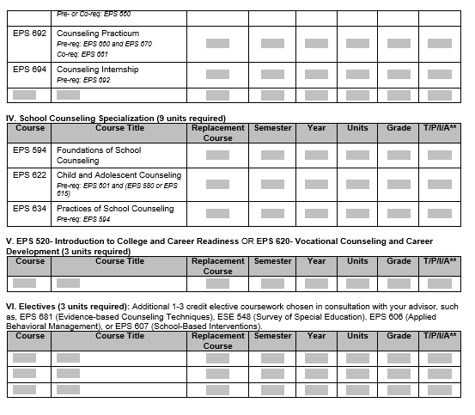
N.4.a Expectations of Students
- Success in a Professional Disposition Evaluation (PDE) is expected and provided by all Counseling faculty to each student. PDE’s are conducted each fall and spring semester to successfully resolve any potential Professional Growth Plans (PGPs) in the timeline designated within the PGP contract. PDE’s including the following domains:
  - Academic
  - Counseling Skills
  - Goals and Objectives congruent with success as counselors, and
  - Personal and Professional Dispositions.
- Students are expected to join their respected professional organizations: the American Counseling Association for CMHC students and AzSCA for School Counselors
- All students are expected to have liability insurance throughout Practicum and Internship and are not allowed to enroll in either course without providing liability insurance documentation.
- Fingerprint Clearance Cards
    - Clinical Mental Health Students: A Non-IVP card is required to provide services during your Practicum and Internship experiences in a mental health setting in Arizona. Your Fingerprint Clearance Card must be obtained and uploaded to your personal documents in Tevera by the end of the Fall semester of your first academic year.
    - School Counseling Students: A NON-IVP card is required to be a student counselor in the Practicum Lab at NAU Campuses as well as in school-based practicum and internship experiences in Arizona.
    - Fingerprint Clearance Cards may be obtained by going to the Arizona Department of Public Safety website (https://psp.azdps.gov/)
      - Log in (create an account) to apply for the card – NOTE cards may take 4-6 weeks so plan ahead as students will not be permitted to participate in the practicum clinic and/or internship with a fingerprint clearance cards
    - Once an account is established with AZ Department of Public Safety – go to Arizona.fieldprint.com to have your fingerprints taken and processed
- Go to Services > Fingerprint clearance cards > SIGN UP with fingerprint.com as a new user
- E-sign content
- Create field print and then schedule – it will give you locations where to get your fingerprint taken and processed.
** Any students looking to do an internship outside the state of Arizona will need to obtain an AZ Non-IPV card and fingerprint clearance through their respective state’s Department of Public Safety

PROGRAM CHECKLIST FOR CACREP MASTER COUSELING STUDENTS

- ____ Complete the CMHC or SC Program of Study with your advisor within the first 2
weeks of your first semester
    - Decide on which elective(s) you will take, and when (total of 3 credits required)
- _____New Students – complete your AZFPCC clearance card by the end of your first Fall academic
year (current students, if you have not done this step, please complete)
- _____ Before practicum ensure you have purchased your liability insurance. You will
NOT be allowed to take practicum or internship without it.
- _____During (or before the end of) Practicum, secure an internship site and
complete internship contract with site supervisor
- ____ Confirm you wish to take the National Counselors Exam with your campus Program
Chair the semester prior to your practicum or internship experience. Successful
completion of this exam will earn you a National Counselor Certification. Your
names will be submitted to the NBCC during (or before) Practicum/Internship.
Work with our National Counseling Exam advisor to schedule a date with NBCC to
take the NCE . (The NCE is usually during Practicum or Internship)
- ____ Successful completion of all coursework prior to Internship, including Practicum

- ____ Apply for graduation on the Grad College website by the deadline of the semester
prior to completion of graduation requirements)
    - Decide if you are going to participate in Mountain Campus commencement ceremony (either at end of fall semester or end of spring semester)
- ____ Complete Internship
    - During internship, think ahead about post-graduate work
- ____ Graduation *** CONGRATULATIONS***
    - Join our Alumni network to stay connected with NAU!
- ____ Apply for Licensed Associate Counselor (LAC) in the state you will be working
- ____ Secure position as an LAC, gather hours and supervision in accordance with AZ
Board of Behavioral Health Examiners’ licensure rules (or other state’s rules if not
in AZ)
    - Keep up with your CEU’s for your National Counselor Certification
- ____ Complete all LAC hours successfully, and apply for LPC (independent licensure)
- ____ Once you are an LPC, be mindful of CEU hours to keep maintain licensure
and continue evolving.

N.4.b. CLASS POLICIES - GRADING PHILOSOPHY IN SELECT COUNSELING COURSES:
EPS 660, 661, 681 (CMHC only) 692, 694
Counseling is both a science and an art. In other words, one may be able to learn the skills of counseling, but if one is unable to apply those skills in a manner which contributes to the overall growth of the client, counseling does not take place. The art of counseling requires timing, vision, involvement, and depth.
- Timing means knowing when and when not to say and do things which will facilitate the counseling process.
- Vision means being able to see where the client has been and where the client needs to go to experience personal growth.
- Involvement means being physically, psychologically, and spiritually with your client at every step of the counseling process.
- Depth means being aware that there is more going on than meets the eye and it means being willing to take the client beyond the superficial to a more meaningful level of interaction.
The assessment of the 'art of counseling' is often a matter of professional judgment. Years of experience are often required to be able to judge whether 'real' counseling is taking place or if one is only going through the motions in a mechanical style. Therefore, instructors will be calling upon their own professional knowledge and experience in counseling and in teaching and supervising counseling to give students meaningful feedback as to their performance.

As a CACREP-approved program, each accredited master program may select and emphasize “special” curricular standards such as Key Performance Indicators (KPIs). KPI’s are applicable within certain classes within the CMHC and SC courses and found in the master syllabi. NAU has selected approximately 10 KPI’s for specific classes with the CMHC and SC and may be found within the master syllabi. Key performance indicators may be knowledge and/or skill based and comprised of quizzes, exams, project rubrics or supervisory scores (practicum and internship).
Key Performance Indicators
- For knowledge-based classes
  - An 80% or above is required to pass a KPI on a project, quiz, or exam – if this grade is not achieved by the student, a remediation plan will be created at the instructor’s discretion.

- For skill-based classes
  - Application of competencies are assessed throughout a student’s practicum and internship experiences by site supervisors and faculty. An 80% is required for passing the designated KPI. If a student does not pass their KPI:
    - the highest grade that may be achieved in these courses is a B.
    - a Professional Growth Plan may be created with the student at the instructor’s discretion.

Grading
- A grade of "A" means...that, in the professional judgment of the instructor, the student has mastered both the art and the science of that class. The student will have clearly demonstrated the knowledge and skill/competencies expected in the course and will have successfully completed all class assignments. The message the grade of "A" should carry to the student is, "You are progressing extremely well in this class, and you should experience success in subsequent counseling skill courses. You are aware of your own strengths and weaknesses and are addressing both appropriately and you have shown exceptional commitment to your work and your profession."
  - An "A" in EPS 660 Counseling Processes means that you are ready to begin seeing clients in Counseling Practicum under faculty supervision. An "A" in EPS 661 Group Processes means that you are ready to begin leading groups with minimal supervision.

- A grade of "B" means...that, in the professional judgment of the instructor, the student has mastered the science of that class, but has some shortcomings regarding the 'art of counseling' It is much less likely that one would master the art, but not the science. Often the student may be blind to these shortcomings and further practice or further work with the instructor and/or a student counselor may be called for. The message the grade of "B" should carry to the student is this, "You are progressing satisfactorily, but your skills are often used in a mechanical manner, and you need more practice to sharpen those skills."
  - A "B" in EPS 660 means that you are ready to begin seeing clients in Counseling Practicum under faculty supervision, but your initial sessions may focus on continuing your practice of the basic skills which were taught in EPS 660. A "B" in EPS 661 means that you are ready to begin leading groups, but co-leading groups with a more experienced student counselor or leading under direct supervision may be advised until you gain more experience in group counseling.

- A grade of "C" means...that, in the professional judgment of the instructor, the student has not mastered the knowledge and/or skill competencies required in the course and must take the course again before taking the next course in the sequence. Specifically, a student receiving a "C" in EPS 660 has not mastered the skills necessary to succeed in Counseling Practicum and therefore cannot enroll in practicum until EPS 660 has successfully been repeated. A grade of "C" is to be given when there is sufficient evidence that repeating the course will prove beneficial to the student. That is, the student demonstrates their potential to successfully complete the retake of the course with additional practice and/or personal growth experiences.

- A grade of "D" means...that, in the professional opinion of the instructor, the student is unlikely to succeed, even with additional practice and personal growth experiences. A student cannot graduate until the course is repeated and a higher grade is achieved.

- A grade of "F" means...that the student is unable to repeat the course. In most cases this will be because, in the professional judgment of the instructor, the student has committed some serious ethical or legal violation or because the student does not possess the mental stability to be effective with clients. A grade of "F" will also be given when there is no evidence of the student having made any attempt to meet the requirements of the course. Serious consideration of alternative endeavors is advised.

In Progress and Incomplete Grades
- A grade of "In Progress" may be given in situations where, in the professional judgment of the instructor, the student is making satisfactory progress toward completing the requirements of the course. Due to some classes requiring course continued supervision after the end of the semester, the "In Progress" may not be possible if supervision cannot be obtained. If a student's progress is questionable at the midterm, the instructor should discuss the possibility of giving a grade of "In Progress" at that time. When given, the message associated with a grade of "In Progress" is that the student appears to have the potential to move on but needs to complete course requirements before a final determination can be made. Also, while a grade of "In Progress" is meant for courses which normally extend beyond the end of the semester, if the course requirements cannot be fulfilled in an additional eight weeks, the student should register again for the entire course. When courses are repeated, both the original and the new grade figure into the student's grade point average.
- A grade of "Incomplete" may be given in situations where, in the professional judgment of the instructor, the student is unable to complete course requirements due to circumstances, such as serious illness, which are beyond his/her control.
- If a grade of "Incomplete" or "In Progress" is not changed by the end of the following semester, the grade remains on the student's record forever as an "Incomplete" or "In Progress", thus neither grade Incomplete or In Progress adversely affects the student's grade point average.

When a student has a graduate assistantship and earns any grade other than an "A" or "B", the instructor should discuss the student's progress with the student's assistantship supervisor if the instructor wants the student to repeat the course but does not want to jeopardize the student's assistantship. Each situation should be handled on an individual basis.

N.5 Academic Appeal Policy

Appeals may be brought forth by graduate students involving certain academic issues and academic decisions within the purview of the Graduate College and its policies and procedures.
The graduate student will use this appeal process for situations involving (but not limited to) the following:
- Dismissal from a program for academic reasons*
- Procedural matters related to admissions, academic progress, thesis and dissertation, and/or comprehensive exams.
- Any academic issues not addressed by other university policies or procedures.

*Please see Academic Continuation, Probation, and Dismissal, and Readmission- Graduate (NAU Policy 100319) for procedures and policies specific to program dismissals.
The graduate student will not use this appeal process for situations related to grievances and violations for which a separate university-wide process exists. These situations include (but are not limited to):
- Grade appeals
- Violations of NAU’s Student Code of Conduct
- Violations of NAU’s Academic Integrity policies
- Discipline-specific ethical standards
- Issues of Research Misconduct
- Issues that fall under the purview of NAU’s Office of Equity and Access

Grounds for Appeal/Burden of Proof
In every appeal, the burden of proof rests upon the student to show the reason why an appeal should be heard. These appeals should only be considered in instances where:
- The faculty, department, school, or other academic unit deviated substantially from accepted and specified standards as established by the University, Graduate College, or academic unit;
- There was a capricious or arbitrary application of standards towards a student;
- Proper due process was denied to the student.

Time Limit on Appeal
A graduate student must initiate the appeal process NO LATER than the end of the next regular term (Fall or Spring) following the date in which the appealable issue occurred. If the faculty member(s) involved with the issue is no longer with the university, the chair, director, or dean of the students’ academic unit will assign a proxy in place of the original faculty member.
If the student fails to submit requested materials or notify the designated administrator within the timeline specified in this policy, such failure will constitute a waiver of the student’s right to an appeal, and the original decision, action, or result from the immediate previous decision will remain final.

Extension of Time
If an extension of time is needed during any phase of the process once the appeal process has been initiated, the party requesting the extension shall petition the Graduate College Dean and present reasons why the deadline cannot be met. The Graduate College Dean will notify all involved parties regarding the granting or denial of the request for an extension with the goal of ensuring fairness and a timely resolution of the problem. If an extension of time is needed by the Graduate College, that notification will come to all parties involved, identifying the number of additional days granted with the goal of ensuring fairness and a timely resolution of the problem.

Definitions
Throughout this policy, the terms “Graduate College Dean” and “Graduate College Associate Dean” includes their designees.

N.6 Written endorsement policy explaining the procedures for recommending students for credentialing and employment:

Students in the CMHC and SC master’s programs are expected to follow the professional code of ethics and certification/licensure guidelines established by the following organizations:
- National Board for Certified Counselors
- American Counseling Association
- Council for Accreditation of Counseling and Related Educational Programs
- And, where relevant: Board of Behavioral Health Examiners - State of Arizona

For MA-CMHC graduates, Counseling Licensure information is as follows:
- Arizona: https://www.azbbhe.us/node/556
- For states outside of Arizona: https://www.counseling.org/knowledgecenter/licensure-requirements/state-professional-counselor-licensure-boards

- For School Counseling graduates, Counseling certification information is as follows:
- Arizona: https://cms.azed.gov/home/GetDocumentFile?id=58fe4f961130c01f0c1cfd36
- For states outside of Arizona: https://www.schoolcounselor.org/school-counselorsmembers/careers-roles/state-certification-requirements

N.7 Policy for student retention, remediation, and dismissal from the program:

N.7.a. Retention
§ Students in the MA/CMHC or SC programs are required to:
- successfully complete all 60 CMHC credits, including passing Practicum and Internship. See Program of Study (above)
- have earned no worse than 2 C’s on their transcript
- have earned A’s or B’s in Counseling Skills courses
  - School Counseling: EPS 660, 661, plus Passing grades in
Practicum and Internship
- CMHC: EPS 660, 661, 681, plus Passing grades in Practicum and Internship
- Successfully resolve any Professional Growth Plans (PGP) if required to do so (which can include violations of ethical concerns)

N.7.b. Remediation
§ Near the end of each semester, all counseling faculty meet during a regularly scheduled Counseling Committee meeting (with impromptu meetings scheduled as needed) to discuss the progress of each student enrolled in the CMHC and SC programs. Students who receive a poor rating on a Professional Disposition Evaluation may receive a Professional Growth Plan (or PGP) if the concern(s) cannot be successfully resolved by the student’s advisor in conjunction with current instructors. The PGP serves as a Remediation plan and includes supportive and remedial goals and outcomes that must be completed within a designated amount of time.
- The PDE form is shown in Appendix A below
- The PGP form is provided in Appendix B below

N.7.c. Dismissal

CONSIDERATION FOR DISMISSAL FROM THE MA CLINICAL MENTAL HEALTH OR MEd SCHOOL COUNSELING PROGRAM: Graduate students are expected to maintain: 1) high academic standards of achievement; 2) consistent and timely progress towards the completion of degree requirements; and 3) high standards of personal conduct and behavior. To assist in maintaining such standards, any one or more of the factors listed below will result in a student being recommended to the Graduate College for dismissal from the program.
- Possessing a grade point average of less than 3.0 in NAU graduate courses during two consecutive semesters or unacceptably low grades in content courses.
- Possessing 3 or more grades that are lower than B.
- Failure to make adequate progress on program requirements including failure to meet the objectives and timeline outlined in the Professional Growth Plan (e.g., excessive delay in completing course requirements; first and second year examinations (if applicable), Practica, Poor ratings on the Professional Disposition Evaluation, our annual continuing student evaluation, commensurate with program and university expectations.
- Any of the following: a) any characteristics which would, in the judgment of the faculty, make the student unsuited to engage in a career in counseling; b) conduct unbecoming of a counselor as outlined by the ACA Code of Ethics or c) failure to comply with departmental, college, and university regulations or procedures.
- Academic dishonesty or research misconduct including cheating, falsification of information, and plagiarism.

University Policy. In addition to dismissal for poor academic performance, certain infractions may warrant the imposition of serious disciplinary measures, including dismissal, without prior discipline having been imposed. Such measures often, but not always, are determined in collaboration with the Office of Student Life, the Office of the Vice President for Research, the Office of Equity and Access, the Graduate College or any other applicable unit on campus.

NAU Program Statement of Inclusion:
We align with the American Counseling Association's (ACA) commitment to diversity, equity, inclusion, and belongingness. As a program and a profession, we respect, honor, and support the uniqueness of individuals across varying multicultural identities, which include but are not limited to sexual and affectional orientation, gender identity and expression, age, race, color, ethnicity, sexual orientation, socioeconomic status, military affiliation, religion or spiritual beliefs, ability, language, national origin, ancestry, and political views. Our counseling program welcomes students and faculty with diverse backgrounds and life experiences to ensure the representation of varying perspectives, worldviews, and ideas. We strive to build inclusive learning spaces in which all students feel their voice is valued and recognized as an asset to the classroom. These beliefs reflect the core values of the counseling profession and echo the sentiment: “Everyone counts, everyone has an opportunity, and everyone welcomed.”

Appendix A: Professional Disposition Evaluation (completed in Qualtrics each semester): http://nau.co1.qualtrics.com/jfe/form/SV_cFRped97M0MDu97

Introduction: During each semester following a student’s admission to an Educational Psychology program, the respective EPS Faculty Committee will evaluate the student’s progress in the program based upon the criteria identified below. This Professional Student Disposition (PSE) is a semester-by-semester opportunity for students to receive feedback about their overall progress in the program, and includes praise for their success and being "on-track", and/or remediation. Students should expect to receive their PDE results via their NAU email address from their Advisor at the end of each Fall and Spring semester, although some might not be received until the beginning of the following semester.

A rating of Needs Remediation means the student exhibits a weakness in that area. If a Needs Remediation is given in any of the given criteria, the student and student’s advisor (in consultation with the Counseling Committee and Educational Psychology Chair) will determine if a Professional Growth Plan (PGP) is needed in order to create goals to remediate the weakness. The PGP process is handled via a PGP contract between the advisor, student, and chair. If the Advisor and the Chair and/or Program Committee determine that the student has met the objectives, activities, and timelines of the PGP, he or she can continue in the program. If the student does not complete the signed PGP contract, or has not met/completed the PGP successfully, he or she may be denied continuance in the program (pending the vote of the EPS Chair and Counseling Committee Faculty).

Student Evaluation Form Information
Demographic information: (name, program, year in program, etc)

Key: Please rate this student on the following dimensions using the following key:

- Needs remediation: Performance did not consistently meet expectations – performance failed to meet expectations in one or more essential areas of responsibility. (may lead to formal PGP)
- Meets expectations: Performance consistently met expectations in all essential areas of responsibility, and the quality of work overall was good.
- Exceeds expectations: Performance consistently exceeded expectations in all essential areas of responsibility, and the quality of work overall was excellent.
- NA = Not applicable: Knowledge and/or skill is not applicable for this item, or, if at mid-term, the opportunity to complete this item has not been available yet.

PDE Domains:
- Academic Aptitude
  - Writing Skills
  - Presentation Skills
  - Research Skills
  - Assessment Skills
  - Content Knowledge
  - Technological Skills
Comments.

- Professional Skill Development
  - Working with Individuals (in Counseling Processes course, etc.)
  - Working with Groups (small group work, working successfully within the cohort, in group
supervision, in the Group course, etc)
  - Leadership Skills
Comments.

- Goals & Objectives
  - Student goals are congruent with success as professional counselor
  - Student is motivated, ambitious, demonstrates consistent effort.
  - Potential to complete program
Comments.

- Professional and Personal Disposition Relevant to Training
  - Openness to Change
  - Awareness of Personal Strengths/Weaknesses
  - Displays Appropriate Personal Adjustment (both professionally & personally)
  - Ability to Work Cooperatively with Others
  - Ability to work successfully with individuals from Diverse Backgrounds
  - Legal and/or Ethical Behaviors
  - Displays Interpersonal Behavior that is NOT Disruptful/Injurious to Students, Faculty, Classes
& Program
  - Professional approach to faculty feedback and supervisory input Comments.

Overall Strengths:

Overall Weaknesses:

PGP this semester? If a student requires a Professional Growth Plan (PGP), the advisor should discuss it immediately with the student, send a draft of the PGP to the Chair, and meet with the student to review the PGP contract in person and obtain the appropriate signatures in order to begin the PGP timeline.

PGP required? YES NO

Appendix B: Professional Growth Plan form 