Botanist/field technician positions
Summer 2023

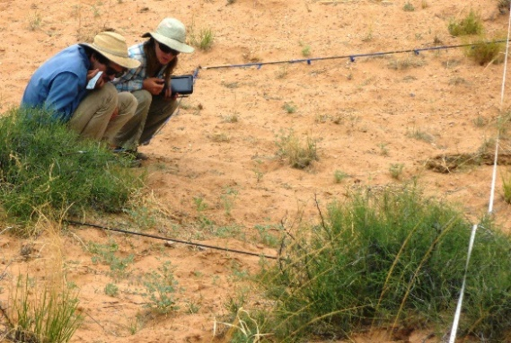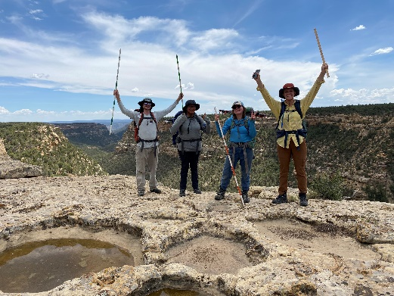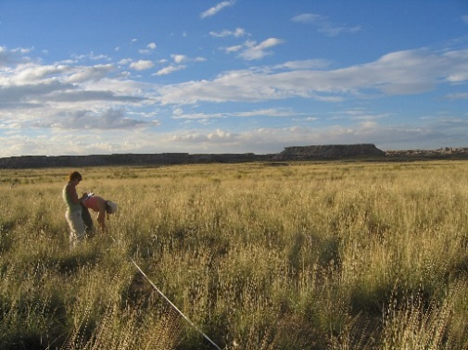

NPS Southern Colorado Plateau Inventory and Monitoring Network through Northern Arizona University

Work as part of field crew sampling vegetation in National Park Service units including Glen Canyon NRA, Grand Canyon NP, Petrified Forest NP, Chaco Culture NHP, Wuptaki NM, Walnut Canyon NM, Mesa Verde NP and Bandelier NM.

This position is based in Flagstaff, AZ but includes extensive travel to national park units across the Southern Colorado Plateau. Hired technicians will use established protocols to collect vegetation data in backcountry locations. The field season begins in May and extends through October. The schedule is typically 8 days on, 6 days off. Crew members should expect to camp in parks for the duration of the hitch. Travel per diem and some camping gear is provided.

We are seeking applicants with the following skills:
- Familiarity with the flora of the Southern Colorado Plateau,
- Experience collecting vegetation and soils data accurately in the field,
- Ability to accurately record field data in tablet computers/paper datasheets,
- Ability to identify plants to species using dichotomous keys and other aids,
- Familiarity with principles of backcountry navigation and safety,
- Exceptional attention to detail and organizational skills,
- Experience with GPS units and Microsoft Office software,
- Ability to respect and get along well with others of varying backgrounds,
- Willingness to spend long hours in the field under sometimes difficult conditions.

Pay $20 hr + per diem.
For more information contact:
Megan_Swan@nps.gov or Hannah_Andrascik@nps.gov
To apply, send resume and 3 references to Hannah_Andrascik@nps.gov
For first consideration, please submit application by 02/15/2023.

