Family Values Assessment

Questions to ask yourself:
- What qualities do you value in other families, friends, or important figures in your life?

- How do you want everyone to feel when you are all at home?

- How do you spend time together and away?

- What character flaws in other people drive you nuts?

- What do you find yourself repeating over and over again to your kids? (ex. Table manners, specific routines)

Reflecting on family values:
- What values did you and your partner grow up with?

- Do you and your family talk about your values?

- What life decisions have you made that tell you about your values?

- What strengths and weaknesses do you have as a family?

Broad categories of values:
Social-friends and family Time
Spiritual, faith, morals, and ethics Character
Work and play Financial
Education Health
Entertainment and technology

Family Values Exercise

Put a star by the top ten values you relate to in this list
From the items you put a star by, circle the top three

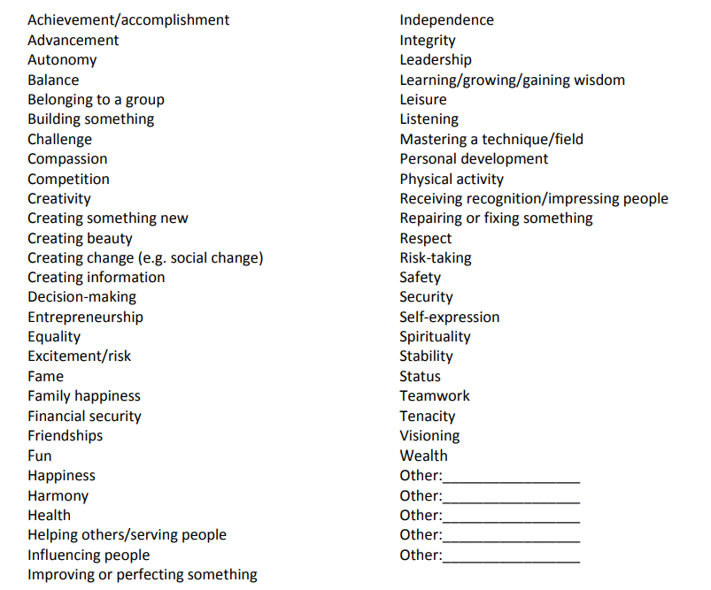

Handout adapted from https://raisingkidswithpurpose.com/defining-family-values/

Child temperament and learning assessment

Questions to ask yourself about temperament (the way we approach and react to the world)
- Does your child prefer to play alone or with other children?

- How does your child typically express their needs or interests?

- Does your child go with the flow, no matter what is happening, or do they prefer routines and order?

- When your child has a problem, how do they handle the issue?

- What is your child’s typical mood or disposition?

Questions to ask about learning styles
- What types of toys does your child prefer?

- Does your child prefer quiet or active play?

- Does your child like to read books and draw pictures?

- Does your child prefer to be shown how to do something or have instructions from an adult verbally?

- Is your child drawn to numbers and patterns?

Broad categories of temperament (about 65% of children fall into one of these categories):
Easy-going (40% of children): happy, regular in sleeping and eating habits, adaptable, calm, and not easily upset
Slow to warm (15% of children): may be less active or tend to be fussy, and may withdraw or react negatively to new situations, but over time they may become more positive with repeated exposure to a new person, object, or situation
Active or feisty (10% of children): fussy, irregular in feeding and sleeping habits, fearful of new people and situations, easily upset by noise and stimulation, and intense in their reaction

Adapted from: https://www.ecmhc.org/documents/CECMHC_IT3_Booklet_Infant.pdf

