Video FAQs for the Undergraduate Symposium

Is a video required?
A video is recommended for poster, oral, and exhibit presentations.

How long should the video be?
For poster presentations, the video should be five minutes long for individuals. For oral presentations, the video should be 20 minutes. Group presenters can make longer videos.

How should I organize my video?
When presenting your research, be sure to include these aspects:
- Introduce yourself and your project
- Present your research question and reasoning as to why this question is important
- Describe the processes you took to conduct your research
- Explain what results you found; include data and figures from your research
- Explain what your results means/why your results are important
- End with a summary of your main points and acknowledgements

Do I need to be visible on screen during my video?
We recommend that you video record yourself speaking and show your poster during your video presentation. One recommended option is to make a Zoom recording on the cloud as this allows for you and your poster to be in the video for the entire presentation. If you choose another method, at a minimum introduce yourself on camera and then conclude your presentation with yourself on camera again, using a voiceover as you present.

What if there is more than one presenter? How should we arrange the video?
Everyone in the group should introduce themselves. We recommend that you video record each speaker. One recommended option is to make a Zoom recording on the cloud as this allows for each speaker and your poster to be in the video for the entire presentation.

How large should the data file be?
The data file should not exceed 2 GB.

What video format should I upload my video in?
Your video should be uploaded in one of the following media types so it can be easily accessed and viewed:

- Zoom
- MP4
- MOV
- AVI
- AAC
- FLV
- 3GP
- MPEG-2

Do you have any other resources or tips on my video presentation?
For more information on your symposium video, refer to the following video on How to Make a Video .

Where can I submit my finished project?
You can submit your final video project on the third page of your Symposium application in OpenWater. Scroll until you see “Video” and select “Choose File” to upload a file from your device. Or you can provide a link to your video.
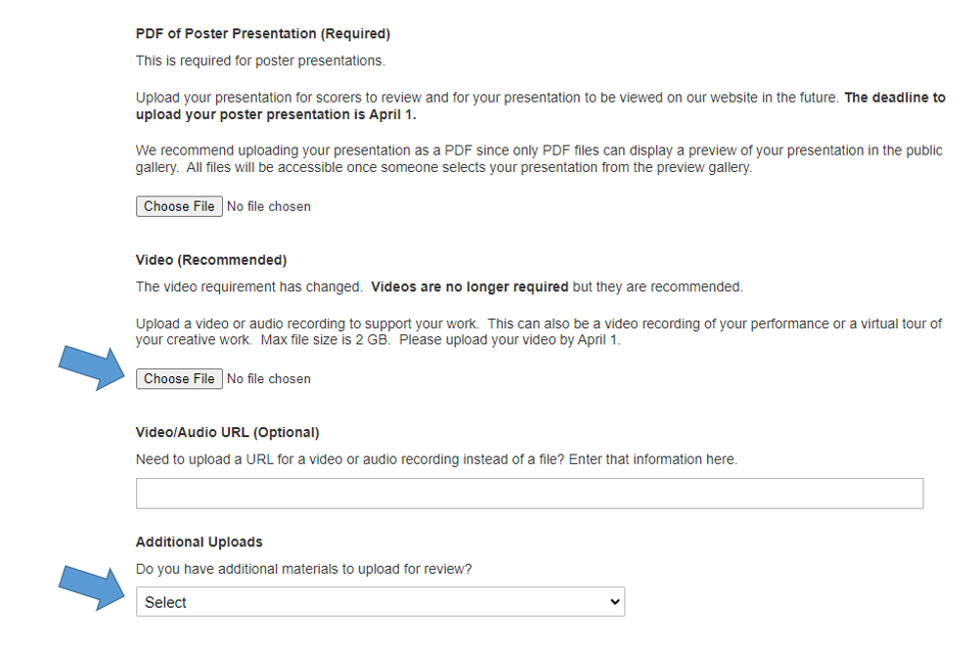

Does the video have to be edited?
You are not required to edit your video, however if you would like to, here are a few sites and programs we recommend:
- iMovie (Apple products)
- Windows Movie Maker (PC)
- Openshot.org
- Clipchamp.com

Who can I contact with more questions?
If you have any more concerns or questions, you may reach out to the Undergraduate Research team at ug-research@nau.edu or 523-5569

