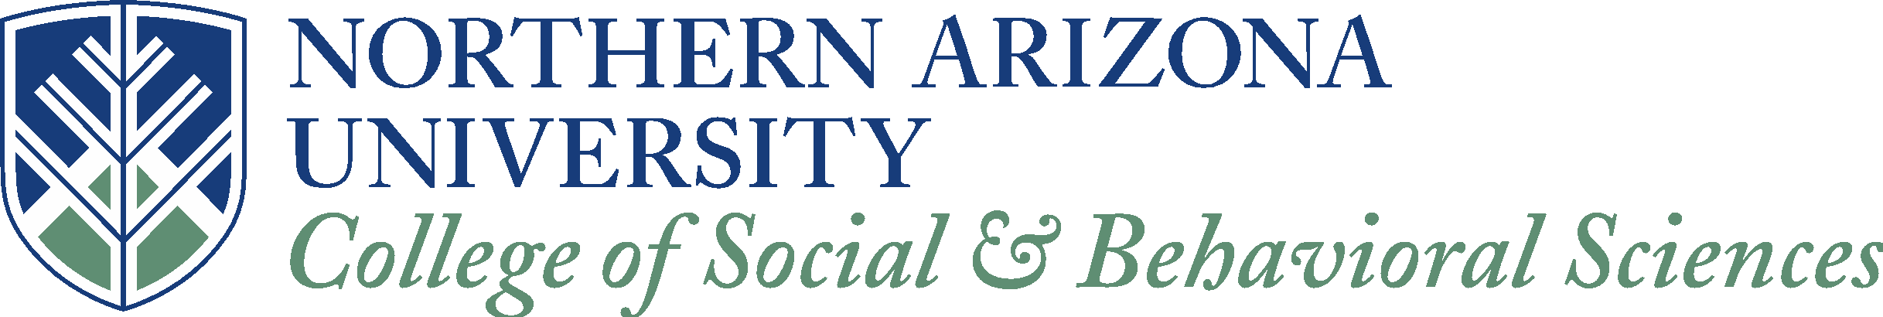

Organization offering internship: Hidden Light LLC / The Framing Department

Contact information (Name/Address/Phone Number):
Matt Beaty / 427 S. San Francisco St. Flagstaff, AZ 86001 / 928-527-1847

When internship is to take place (Fall, Spring, Summer, Ongoing): Ongoing - one-semester increments.

Type of Internship Offered:
Photography Intern: Darkroom and Framing

Compensation (If the internship offers any kind of compensation, please list that here): Experience, prints, and the opportunity to produce a photography show and hang it in the Hidden Light building for one month at the completion of the internship

Total number of hours of work per week: 15-20

Total number of weeks (Please note that during the Fall and Spring semesters, a semester lasts 16 weeks, and for the Summer, the semester lasts 12 weeks): 16 weeks

Special skills required:
Attention to detail and strong communication skills are paramount.
An interest and knowledge of photography and related jargon is also required.
Familiarity with Google Apps (gmail, google drive, etc) as well as the Adobe Suite (LR, PS) and the apple operating system are preferred.

Please provide any additional information for interested students:

Hidden Light LLC
Internship Opportunity: Darkroom and Framing intern.

Description:
Hidden Light LLC is a commercial darkroom and photographic resource specializing in hand-made fine-art printmaking. The Framing Department is a custom framing shop dedicated to helping artists display their works in the best way possible.

The two operations are in the same building and are run by the same staff. We are seeking a part-time (15-20 hours/week) intern who will have the opportunity to work in both areas; printing and framing.

Responsibilities will include:
- Customer service, phone calls and administrative tasks
- Ensuring the gallery is kept clean and presentable
- Taking orders for printing, film development, and framing
- Assist with special events, including show openings, workshops, and client visits
- Assisting with darkroom as well as digital printing
- Assisting with frame preparation and presentation

Qualifications and Skills
Candidate must be organized and self-motivated. Attention to detail and strong communication skills are paramount. An interest and knowledge of photography and related jargon is also required.
Familiarity with Google Apps (gmail, google drive, etc) as well as the Adobe Suite (LR, PS) and the apple operating system are preferred.

Benefits
While the position is unpaid, the successful candidate will have the opportunity to make prints of their own photographs with each printing process we offer; silver gelatin, piezography, platinum palladium, and color inkjet. The intern will also be allowed to process their own black and white film for free while learning to use the JOBO Autolab. Framing materials will also be provided at cost for the intern to prepare their own material for a show.
At the conclusion of the internship (one semester, or 4 months) the intern will be offered the gallery space in the building to produce and hang their own photography show for one month, free of charge.
If applicable, school credit is offered for this internship.

How to Apply
Bring resume and cover letter in person to Hidden Light LLC. Interviews will take place the first week of February, 2017

