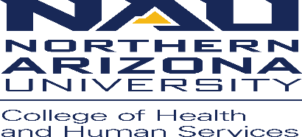
Communication Sciences and Disorders, Speech-Language-Hearing Clinic
Policies and Procedures

Policy: HIPAA Privacy notice policy #2
Procedure:
- All clients who come to the NAU Speech-Language-Hearing Clinic for services of any kind are required to be given an “Acknowledgement of Receipt of Notice of Privacy Practices” to read and sign before they are seen for services. This includes all Audiology and Speech therapy clients.
- The clinic must receive the signed copy, which includes the clients printed name, signature and date. The relationship to the client must be signed by a personal representative, if applicable.
- This form is to be uploaded into the client’s electronic medical record.
- The form is then shredded.
- The client should always be offered a copy of the Acknowledgement for their records.
- If, for any reason, this form is unable to be completed, office staff must fill out the very bottom of the first page of the form.
- In the event that the Privacy Practices change and the form is revised, every client will need to resign the form. This will occur as each client comes in for their next Audiology or Speech therapy appointment. The form will then once again be uploaded into their electronic medical record, and then shredded.

