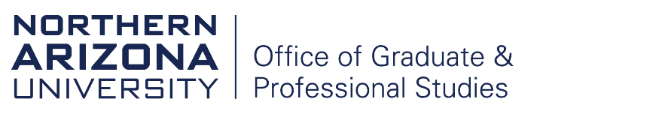

Master’s in Passing / Fall Back Request Form

To be eligible, students must meet all university requirements (Policy 100811: Requirements for Master’s Degrees), be in good academic standing (Policy 100319: Academic Continuation, Probation, Dismissal, and Readmission), and have successfully completed all master’s degree requirements in the NAU Academic Catalog. Please note that a Master’s in Passing may affect your Satisfactory Academic Progress (SAP) with Financial Aid. Please contact the Department of Scholarships and Financial Aid for further information.

For detailed information on the difference between a Master’s in Passing and a Fall Back degree, please refer to Policy 100805: Requirements for the Doctoral Degree, PhD.

Student Information:
Student name: | Student ID:
Advisor/Faculty Mentor: | NAU Email:
Department Chair/Director:
Current doctoral program (e.g., Biology, PHD):

Degree Information:
Proposed master’s degree (e.g., Biology, MS):
Emphasis, if applicable:
Expected graduation term for the master’s degree (e.g., Spring 2021):

Student signature: Date:

*International students only: Proof of ISSS advising is required before this form may be submitted.
ISSS advisor printed name: Date:

ISSS advisor signature:

TO BE COMPLETED BY THE ACADEMIC UNIT
Master’s in Passing □ Fall Back □

Is the student required to complete a thesis for the master’s degree? □ Yes □ No

Master’s level comprehensive exams may be waived if the student successfully passed their doctoral comprehensive exams. If this requirement will be waived, indicate the date on which the doctoral comprehensive exam was successfully completed:

Approval of this form indicates that the student has met, or will meet, all master’s degree requirements before the end of the expected graduation term indicated above.

Advisor/Faculty Mentor printed name: Date:

Advisor/Faculty Mentor signature:

Department Chair/Director printed name: Date:

Department Chair/Director signature:

Submit completed form to: GradAdmissions@nau.edu or GradInternational@nau.edu (for international students only)
Revised 8.7.2023

