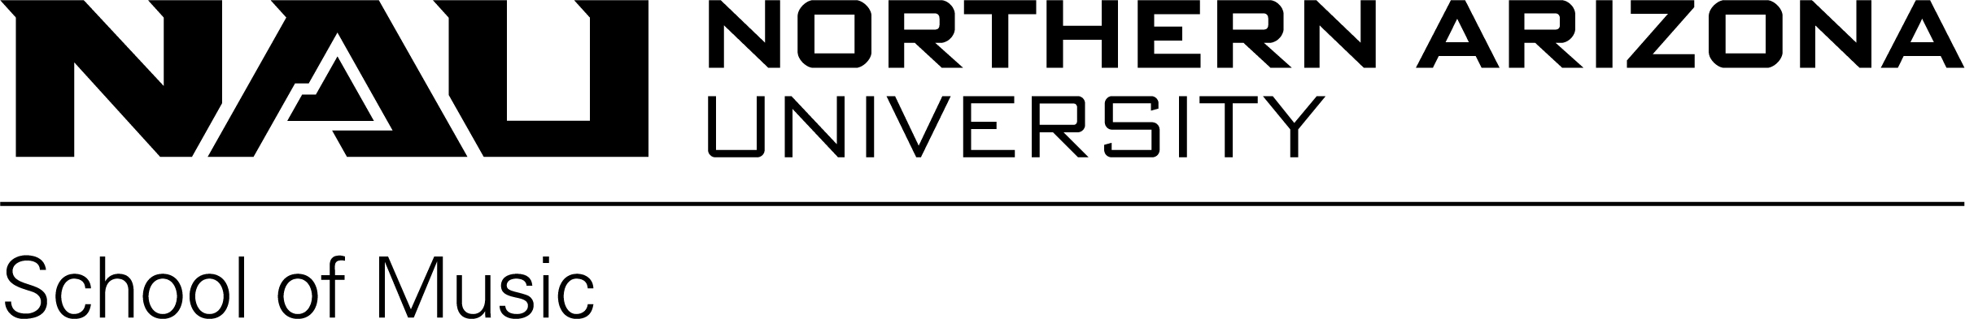
October 30, 2020

Dear Choral Director:

YOU’RE INVITED!!!

The Northern Arizona University choral and vocal faculty would like to take this opportunity to cordially invite you and your ensemble(s) to participate in the 2021 NAU Vocal Jazz & Madrigal Festival, jointly sponsored by NAU Choral Studies and the NAU Student Chapter of the American Choral Directors Association. This event will be held VIRTUALLY on Thursday, February 11th through Saturday, February 13th, 2021. The festival is a noncompetitive and non-rated festival and ensembles of all ability levels are invited to participate!

REGISTRATION TYPES & COST

Because of the unprecedented times we are currently in and the unique challenges facing each choir director, we will be offering three different types of registration this year: Non-Performer, Performer (without plaque), and Performer (with plaque).

Non-Performer Registration ($100.00) will allow you and your students to watch other groups perform, attend the lunch-time masterclasses and workshops presented by our clinicians, and watch the NAU Shrine of the Ages Choir and High Altitude Vocal Jazz Ensembles perform.

Performer Registration (without plaque, $150.00). In addition to all of the items listed above, schools that choose this option will also submit an audio or video recording of up to fifteen (15) minutes in length and receive thirty minutes of audio recorded comments from two clinicians and a fifteen minute live clinic (via Zoom) with a third clinician.

Performer Registration (with plaque, $200.00). In addition to all of the items listed above, schools that choose this option will have a 2021 Jazz Madrigal Plaque mailed to you.

Initially, we will accept only TWO ensembles per director. Additional ensembles will be accepted only after all applicants have been given the opportunity to schedule an ensemble. Available slots will be assigned to additional ensembles after the November 23 – November 25th registration period. Entry fee is due by Friday, December 18th, 2020. If the entry fee is not received by December 18th, 2020 reserved times will be given to the first school on the waiting list and your school will be moved to the bottom of the waiting list.

REGISTRATION PROCEDURE

In an attempt to make the sign-up and assignment of performance times more efficient, please note the following:

- Performer registrations will be accepted from 7:00 am MST Monday, November 23rd until the festival is full. We do receive a high number of registration forms right at 7:00 am so if you send us a form at 7:03 am it is likely you will not get your first choice for time or clinician. Directors will receive an email confirmation shortly after form is received; if you have not heard from us, it is your responsibility to contact us, as we may have not received your registration.

- Non-Performer registrations will be accepted from 7:00 am MST Monday, November 23rd until the festival is full.

- Registration will be accepted via EMAIL ONLY (no faxes) at ruth.solin@nau.edu. To access the form online please go to http://nau.edu/CAL/Music/Choral-Studies/Jazz-Madrigal-Festival. Download the Jazz/Madrigal Entry Form and fill it out using Adobe Acrobat or Microsoft Word. Please be sure to indicate on the registration form your order of preference for date and time as well as clinicians. (Please remember to print the registration form for your records and save a copy)

FESTIVAL LOTTERY: In an effort to make the registration process fairer, all performer registration forms that are time-stamped between 7:00-7:01, 7:01-7:02, and 7:02-7:03 am will be placed in a lottery to determine the order in which schools are assigned festival times and clinicians. All forms time-stamped after 7:03 am will be assigned spots on a first come, first served basis.

FESTIVAL SUBMISSION FORMAT & DEADLINE
Performing ensembles should submit an audio or video file for the festival, not to exceed 15 minutes in length. (Video is preferred). For some schools, this may mean submitting three memorized song and for some schools it may mean just one song with the students using music, which is OKAY. We want to help you and your ensemble no matter where you are on the musical journey. Your audio or video files, plus pdf copies of your music will need to be submitted by Monday, February 8th at noon.

FESTIVAL “SITES”, FLIGHTS, & CLINICIANS
Festival submissions will be organized into flights of three based on the modality of their teaching (full in person, hybrid, and online) and the videos will be played back-to-back-to-back. Here is an example of one flight:

8:00 AM | South Flagstaff HS | Clinician – Dr. Singmaster
8:15 AM | West Flagstaff HS | Clinician – Dr. Vocalese
8:30 AM | North Flagstaff HS | Clinician – Dr. Diction
8:45 AM | Clinic
9:00 AM | Break

During your “performance”, two clinicians will provide audio commentary and the third clinician will take notes and have a live clinic (via Zoom) with you during the “clinic” time. So, in the example above, South Flagstaff HS would get audio comments from Dr. Vocalese and Dr. Diction but have an actual clinic with Dr. Singmaster. You and your students will need to stay for the entire flight (each one lasting an hour) so that you can support the other schools in your flight.

Because the festival is virtual, we are able to bring in many of the best clinicians from around the country. Some MADRIGAL CLINICIANS that have already agreed to participate in the festival include: Jeffrey Ames (Belmont), Andrew Crane (BYU), Cari Earnhart (CSU Fresno) Josh Habermann (Santa Fe Desert Chorale), Jessica Napoles (North Texas), Joshua Palkki and Jonathan Talberg (CSU Long Beach) and Steve Zielke (Oregon State). JAZZ CLINICIANS so far include: Jennifer Barnes, Julia Dollison, Rosana Eckert, Jeremy Fox, Sara Gazarek, Christine Guter, and Kerry Marsh.

For an up to date list of clinicians and their bios, please click here

HOST CONCERTS
A free, livestreamed concert featuring NAU Shrine of the Ages Choir and NAU High Altitude Vocal Jazz Ensemble will be made available to all festival participants and will stream on Thursday, February 11th and Friday February 12th at 6:00 pm MST.

SENIOR AUDITIONS
The NAU School of Music is committed to the health and safety of our students, faculty, and staff, as well as prospective students and their families. In this spirit, we have moved all auditions for Fall 2021 admission to our online screening platform. For more information please visit https://nau.edu/music/admissions

IMPORTANT DATES TO REMEMBER
Monday, November 23rd , 7:00am MST Festival Registration is Open - Email: ruth.solin@nau.edu (no faxes)

Tuesday, December 1st Festival Performers will be notified of Performance Times and
Clinician via email & website

Friday, December 18th Payment must be received by the NAU Choral Studies Office or
your ensemble(s) will lose their reserved time slots.

Friday, January 18th, 2021 Last day to withdraw from the festival and receive a refund

Monday, February 5th, 2021, Noon MST Audio & Video Files should be submitted by all performing ensembles.

We look forward to your participation in this year’s festival and the opportunity to hear your choral ensemble(s). If you have any questions or concerns regarding any facet of the festival, please call Ruth Solin, NAU Choral Studies Administrative Associate at (928) 523-5190.
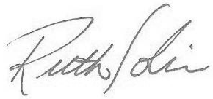
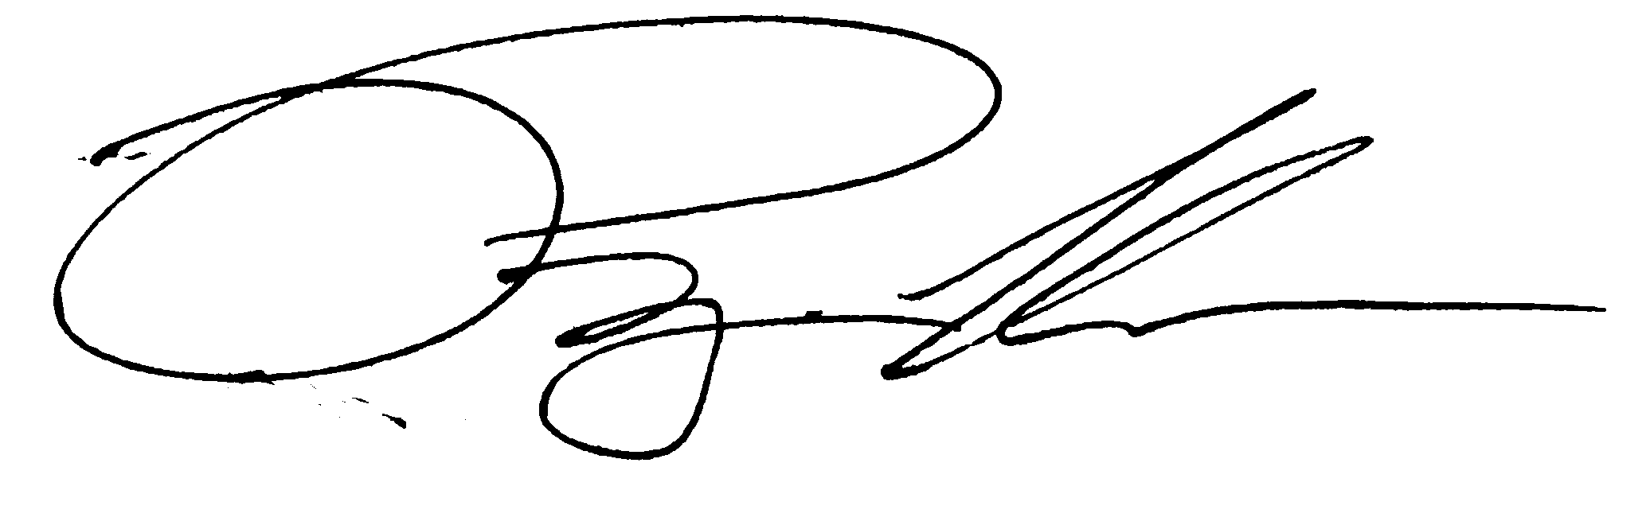
Sincerely,

Ryan W. Holder, DMA Ruth Solin
Associate Director of Choral Studies Administrative Associate
NAU Jazz/Madrigal Festival Coordinator NAU Choral Studies Program

