2019 Senior Camp Percussion Requirements
- Major scales, MEMORIZED, through five flats and sharps (marimba or xylophone)
- Selected basic snare drum rudiments
- Prepared pieces for snare drum, marimba/xylophone, and timpani [see below]
- Sight reading on snare drum and percussion keyboard—to be provided by adjudicator
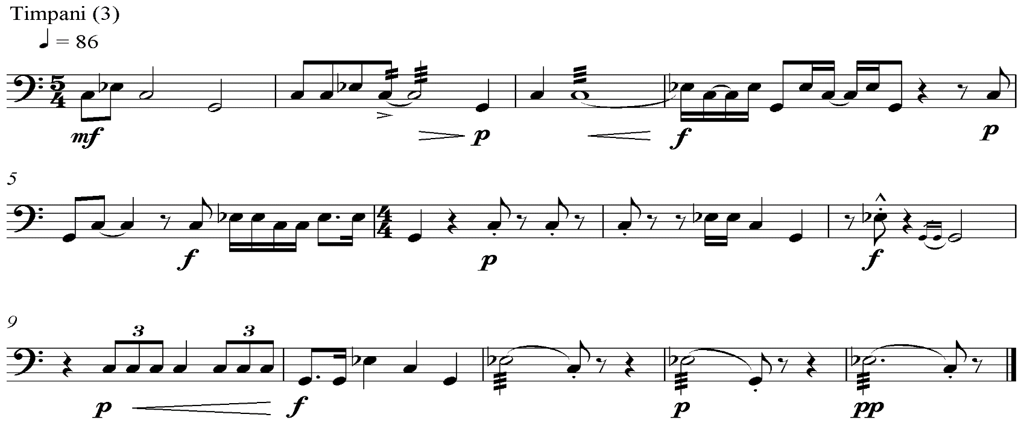
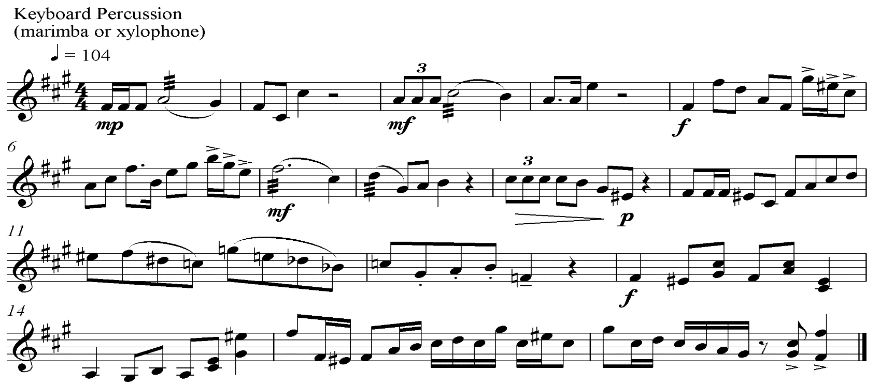
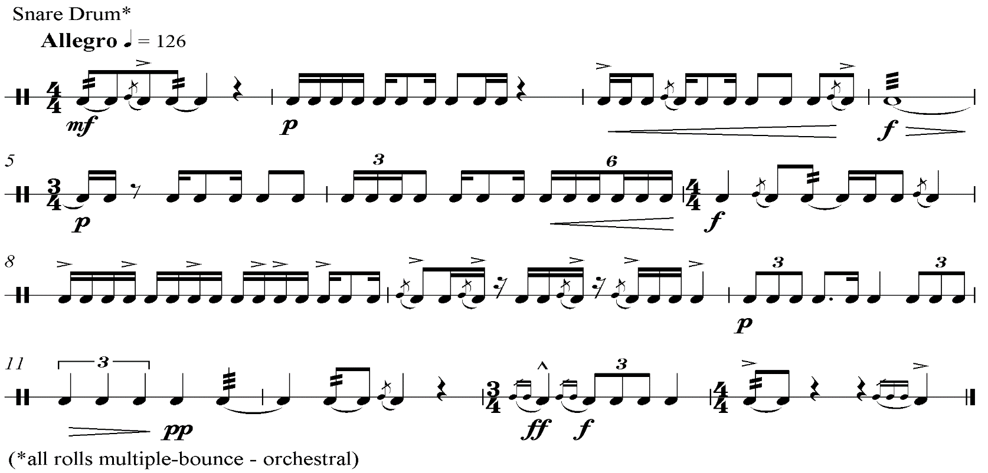

Important Info for Percussionists!

Be sure to bring all sticks, mallets, and brushes for your ensemble and classroom needs.

ALL PERCUSSIONISTS (Band and Orchestra) NEED TO BRING:
- Practice pad
- Concert snare drum and stand, with carrying case (large ensembles are not equipped with snare drum)
- Concert snare drum sticks
- Yarn mallets (set of 2 and/or 4) for marimba, vibraphone, and suspended cymbals
- Timpani mallets
- A pair of harder/appropriate mallets for xylophone and bells (avoid brass please)

If you are selected for a jazz ensemble or combo, a drum set will be provided for classes, rehearsals, and concerts but you will need to supply your own:
- Cymbals (in a personal cymbal bag)
- 1 ride cymbal
- 1 crash cymbal
- 1 pair of hi-hat cymbals
- Drum set sticks and brushes
- Optional: extra cymbal stand for an auxiliary cymbal if desired and if you bring the cymbal

Please don’t ask to share or borrow these items! It is recommended that percussionists come fully prepared, perhaps making arrangements to borrow items within their local community or contacting a local music store, if necessary.

