*Audition materials found on the following page*

2019 Curry Summer Music Camp at NAU
Oboe Reed Making Class and English horn at Camp

A special reed making class for oboists during senior camp will be offered. This class is in addition to your oboe master class. During the class sessions, student will learn the steps to making oboe reeds from wrapping to finishing. Special equipment is required for these classes.

THE FOLLOWING EQUIPMENT SHOULD BE BROUGHT WITH YOU TO MUSIC CAMP

1 double hollow ground knife
1 flat oboe plaque
1 case to carry your supplies (opt.)
6 oboe tubes, brass, 47mm in length (start saving your own to bring to camp but make sure they fit your mandrel.)
6 pieces of oboe cane, gouged, shaped, and folded
1 piece of beeswax (found in fabric and candle stores)
1 six inch ruler with metric on one side and inches on the other (most rulers are made this way)
1 oboe mandrel
1 small wooden cutting block
1 spool FF nylon thread

CAMP WILL NOT FURNISH THESE ITEMS, YOU MUST BRING THEM WITH YOU!

There are many excellent oboe supply companies that sell oboe reed making equipment. However, there are two oboe shops from which you can get these supplies online. Reed Kits from Mark Chudnow Woodwinds are available for purchase. These are the top quality tools that you can use far into the future. To order call (800) 780-4340 or visit www.mcwoboe.com. Allow two weeks for delivery. Dr. Scarnati recommends the “First Oboe Reed Kit” with an upgrade to the deluxe hollow ground knife and gouge cane only if possible (she will be happy to shape the cane for you). If you are in the Phoenix area, you can also purchase kits from Weber Reeds in Chandler 877-932-7332 or 480-726-6800 (www.webreeds.com). If you have any questions, email Rebecca.Scarnati@nau.edu.

Dr. Scarnati will have some gouged and shaped cane available for purchase ($2 per gouged and shaped piece) on a limited basis.

English horn at Camp
Oboe students who are interested in playing English horn are encouraged to bring their own instruments (when available) and reeds. English horn reeds purchased at camp will cost $20 per reed. There are not always English horn parts in the ensembles but we will use them in master class.

*Audition materials found on the following page*

2019 Senior Session Oboe Requirements
(If you would like to audition on English horn as well, please prepare the final etude below)
- Major scales, MEMORIZED, through three flats and sharps (1 octave minimum)
- Chromatic scale, MEMORIZED (1 octave minimum)
- Two prepared etudes (see below)
- Sight reading—to be provided by adjudicator
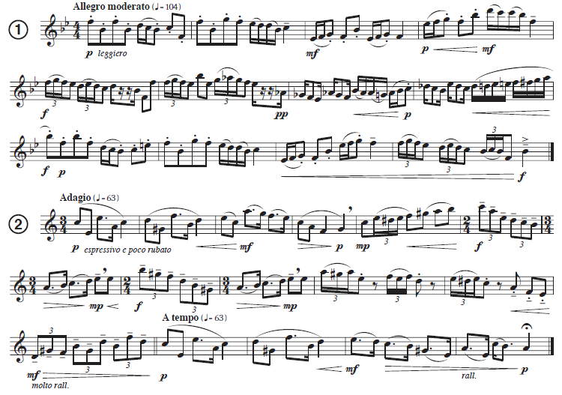

English horn Etude
