2019 Junior Session Saxophone Requirements
- Major scales, MEMORIZED, through two flats and sharps (1 octave minimum)
- Chromatic scale, MEMORIZED (1 octave minimum)
- Two prepared etudes listed for both alto, tenor and baritone saxophones (see below)
- Sight reading—to be provided by adjudicator

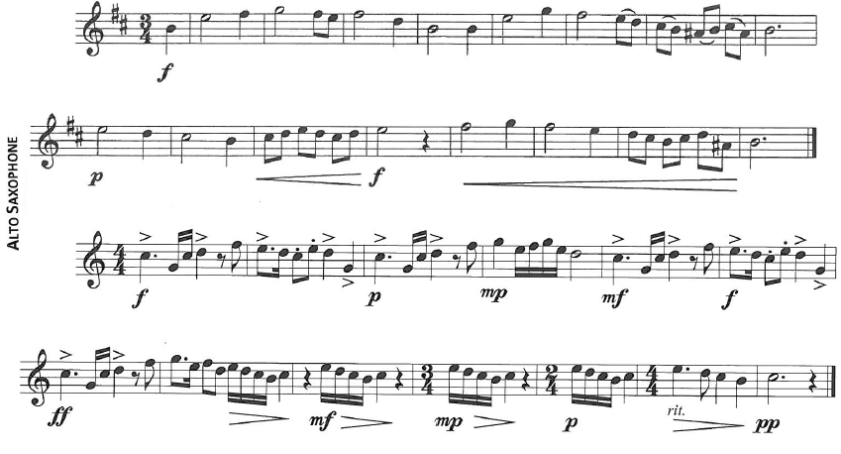

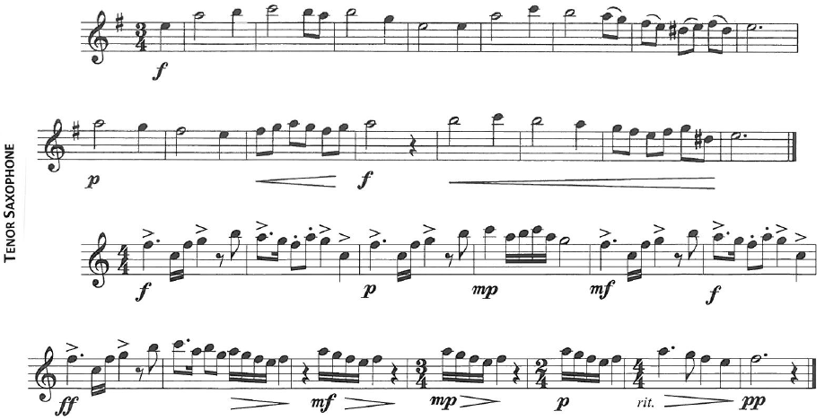
*Please note that Tenor saxophone etude #2 is in the key of F and should have a B flat in the key signature.

