STEP 1: Apply to Northern Arizona University
- Go directly to https://nau.edu/admissions/how-to-apply/

- Select Online

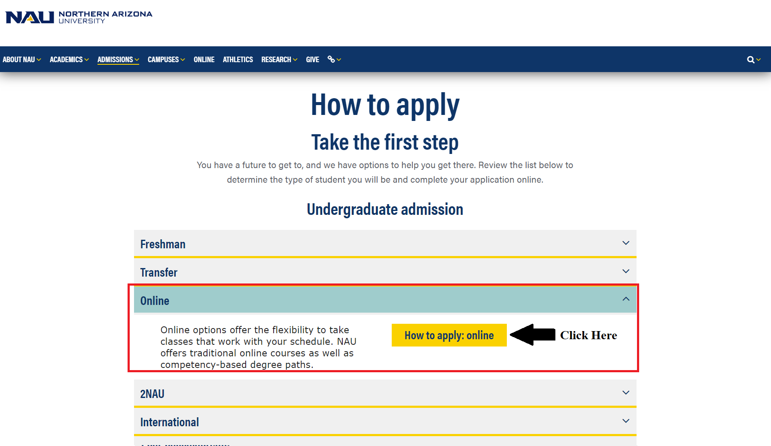

STEP 2: Select Freshman or Transfer, according to your applicant type.

  - If you have completed 11 or less transferable college credits since high school graduation, you must apply as a freshman.
  - If you have completed 12 or more transferable college credits at another college or university (since graduating from high school), you must apply as a transfer.

STEP 3: Click Continue to start filling out biographical details, as well as education history.
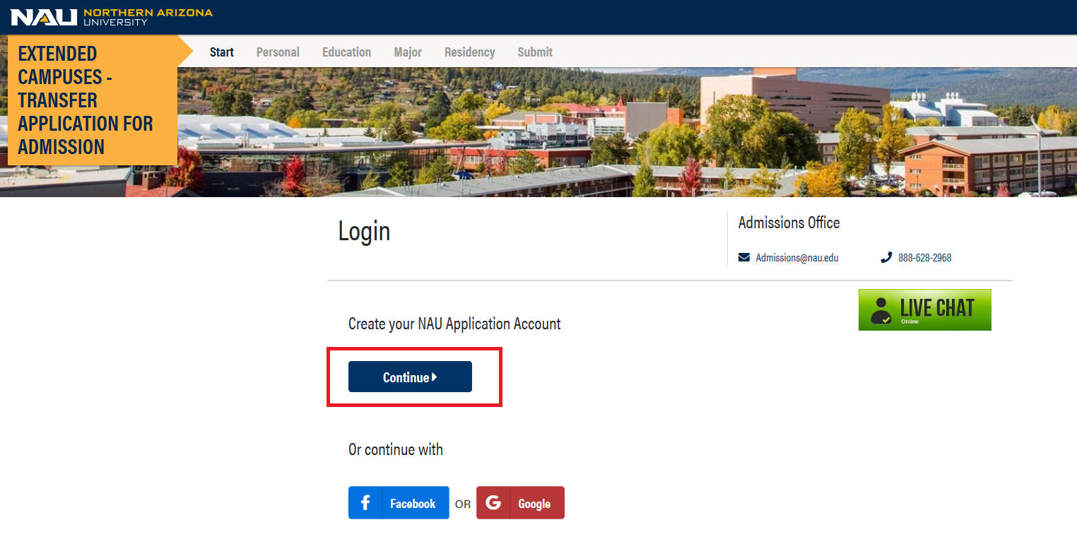

STEP 4: Under the Enrollment and Major section of the application, select the term for which you want to apply.
  - Under Campus you will select “ONLINE”
  - Under Choose Major you will Select “EXPLORATORY”

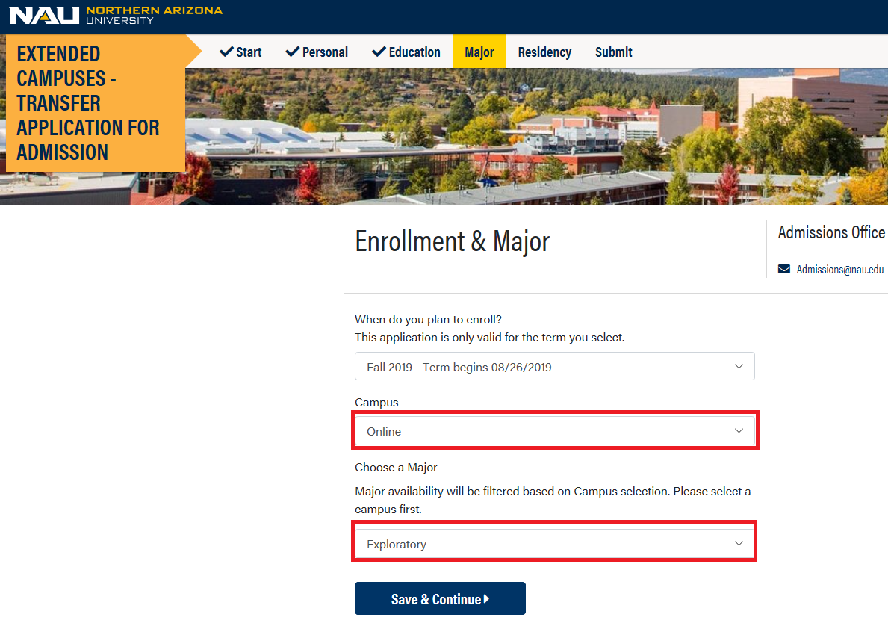
STEP 5: You will be asked to upload your transcripts, as a 401-Series applicant you can SKIP this step simply by clicking the continue button.
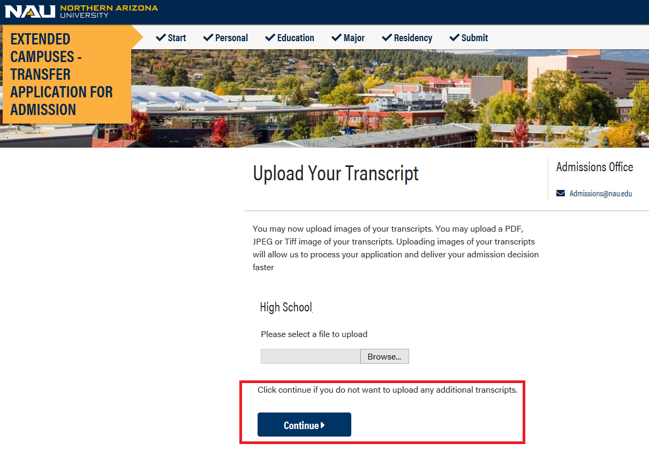
STEP 6: Pay the $25 application fee with an e-check or credit card.
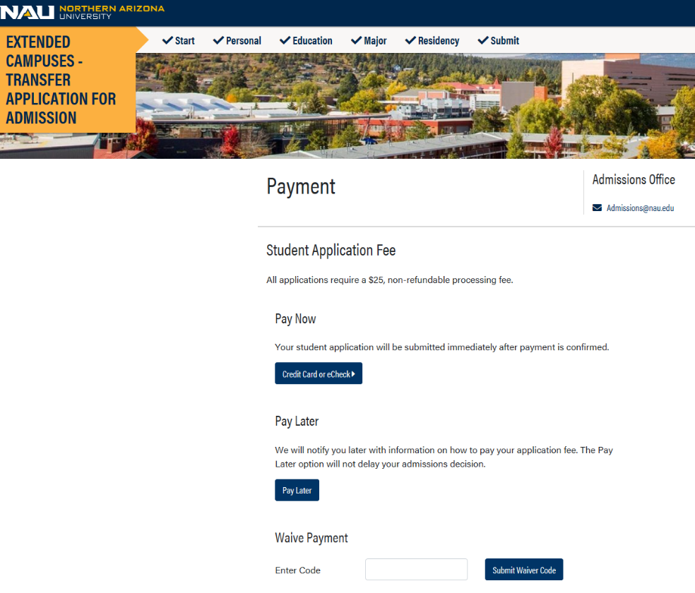
STEP 7: Once you have completed, submitted, and paid for your application, please send an email to 401series@nau.edu to notify the School of Forestry that you have applied and to request membership in the “Federal Agency Training” Student Group. (You will not be able to enroll in 401-Series courses until you are in this student group.)

